|  |  |
| --- | --- |
| ロゴ01(CF0433)-ol.eps | 780-WI-355 |
| Manual |

**Purchase Process Management System Manual**

|  |  |  |  |  |  |
| --- | --- | --- | --- | --- | --- |
| Version | Date | Reason | Apply in Viet Nam | | |
| Approval | Confirm | P.I.C |
| Translate/Make |
| E00 | 22/03/2021 | New | T.Ambo | Cuong-14062 | Phong-18026 |
| E01 | 29/04/2021 | Add ThemeNo, Budget Description to screen: Create New PR, Update PR, Clone PR | T.Ambo | Cuong-14062 | Phong-18026 |
| E02 | 04/06/2021 | New modules: Import, Export Request, Export Request Check, Export Order, Vendor Claim, Supplier Check, Contract Principles, Mistake Type, Tag management. |  |  |  |
|
| T.Ambo | Cuong-14062 | Phong-18026 |

|  |  |  |
| --- | --- | --- |
| **Keyword** | Software |  |
| User guide |  |

Table of Contents

I. For User 1

1. Login 1

2. Product Category 2

a. View Product Category list 2

b. Create a new Product Category 3

c. Edit Product Category 4

3. Product Item 5

a. View Product Item list 5

b. Create a new Product Item 6

c. Edit Product Item 7

d. Delete Product Item 8

4. Purchase Request 9

a. View PR list 9

b. Create a new PR 10

c. Edit PR 11

d. Clone PR 12

e. Detail PR 13

f. Print PR 14

5. Export Request 15

a. ER List: 15

b. Create New ER: 16

c. Update ER 16

d. Clone ER 17

e. Detail ER 17

f. Print ER 18

II. For PP Group 19

1. Login 19

2. Unit 20

a. View Unit list 20

b. Create new Unit 21

c. Edit Unit 22

3. Vendor 23

a. View Unit list 23

b. Create new Vendor 24

c. Edit Vendor 25

d. Delete Vendor 26

4. PR Check 27

a. View Unit list 27

b. Confirm PR 28

c. Return PR 29

5. Purchase Order Item List 30

a. View PO Item list 30

b. Create new PO 31

c. Edit PO 32

d. Detail PO 33

e. Payday 35

f. Receipt 36

g. Print PO 37

6. Export Request Check 38

a. Export Request Check list: 38

b. ER detail 39

7. Export Order 40

a. Export Order list: 40

b. Export Order create: 41

c. Export Order edit: 41

d. Export Order Detail: 42

e. Export Order Item list: 42

8. Import 43

a. Import list: 43

b. Create new Import: 44

c. Create new Import: 44

d. Update Import: 45

e. Detail Import: 45

f. Import Item list: 46

9. Vendor claim: 47

a. Export Order list: 47

b. Create new Claim: 47

c. Edit Claim: 48

d. Edit Claim 48

10. Contract Principles: 49

a. Contract Principles list: 49

b. Create new Contract Principles: 49

c. Edit Contract Principles: 50

d. Delete Contract Principles: 50

11. Supplier check: 51

a. Supplier Check list: 51

b. Create new Supplier Check: 51

c. Edit Supplier Check: 52

d. Delete Supplier Check: 52

e. Detail Contract Principles: 53

12. Mistake Type: 54

a. Mistake Type list: 54

b. Create new Mistake Type: 54

c. Edit Mistake Type: 54

13. Tag: 55

a. Tag list: 55

b. Create new Tag: 55

c. Delete Tag: 56

# For User

## Login

Go to internal website and click to “PPM” icon: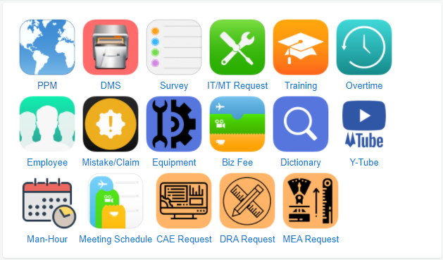

After login into system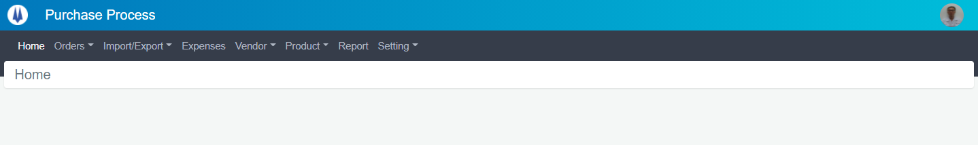

## Product Category

### View Product Category list

To view product category list, click to “Product” menu and click to “Category”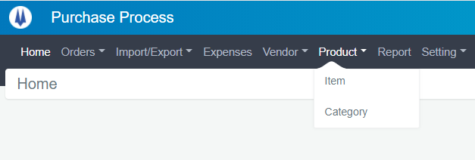

Product category list page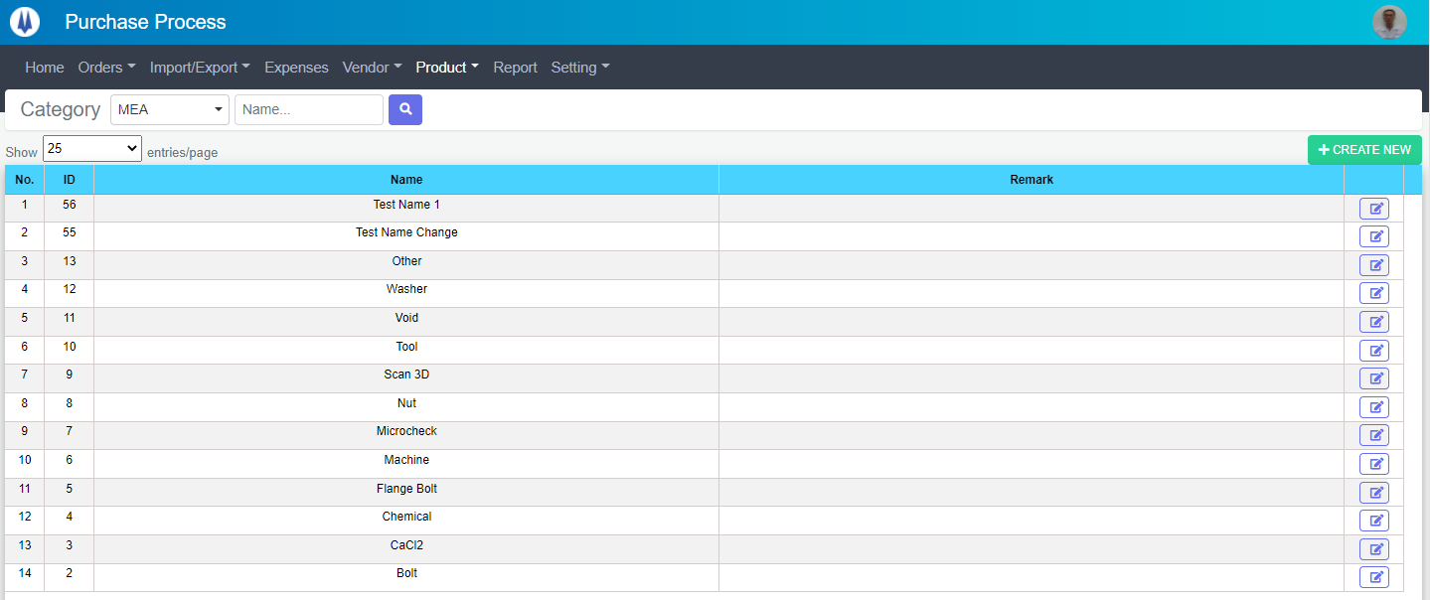

You can filter by Section and Category Name

### Create a new Product Category

Click to “Create New” button

A new modal will be displayed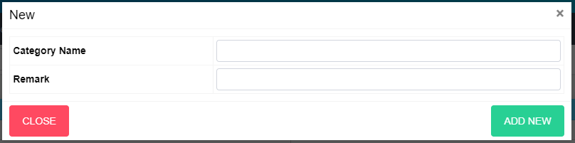

Input data and click “ADD NEW” button to create new Product Category. If you want to cancel this work click “CLOSE” button.

### Edit Product Category

At the Product Category list page, click to “Edit” button (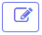)

The modal for edit will be displayed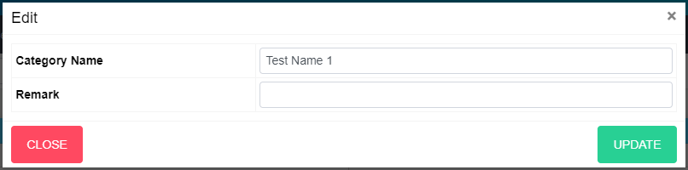

Edit equipment category’s info and click “UPDATE” button to update this category. If you want to cancel this work click “CLOSE” button.

## Product Item

## View Product Item list

To view Product Item list, click to “Product” menu and click to “Item”

Product Item list page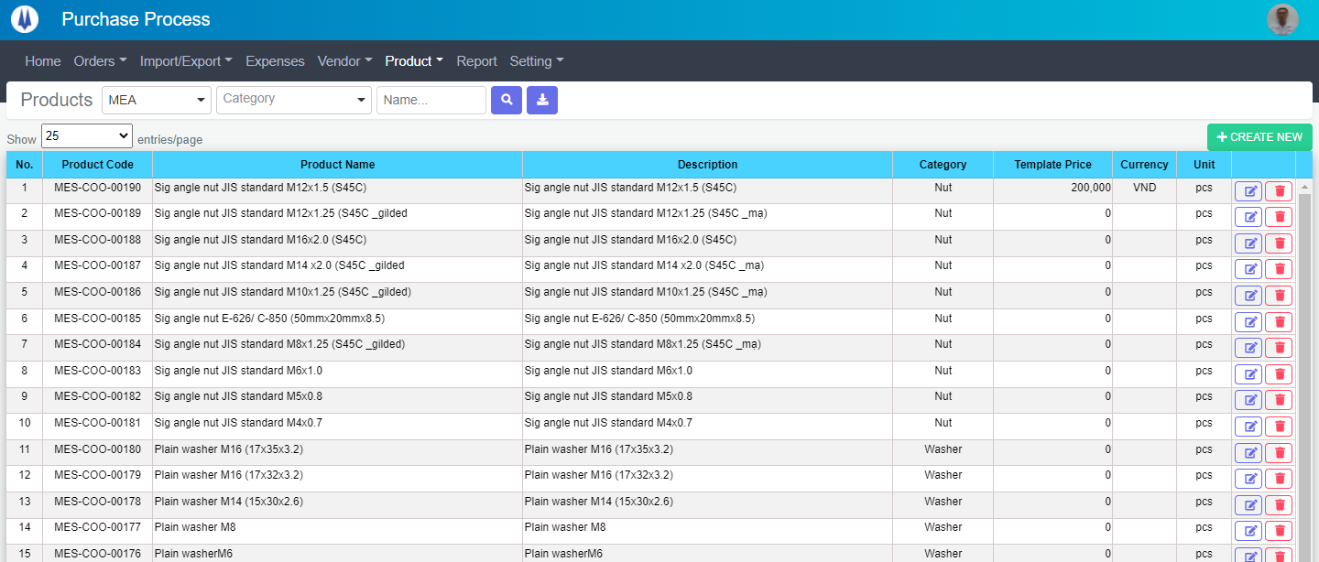

You can filter by Section, Category, Product Name

### Create a new Product Item

Click to “Create New” button

A new modal will be displayed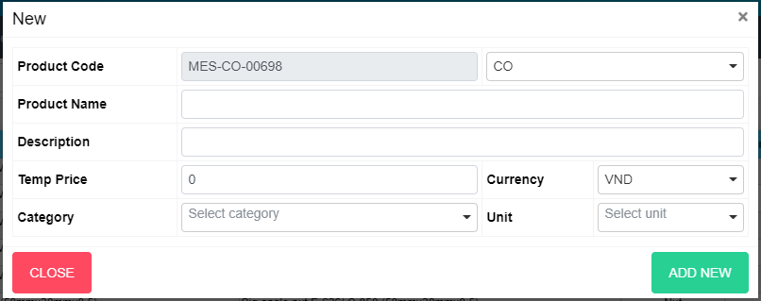

Input data and click “ADD NEW” button to create new Product Category. If you want to cancel this work click “CLOSE” button.

### Edit Product Item

At the list page, click to “Edit” button

The modal for edit will be displayed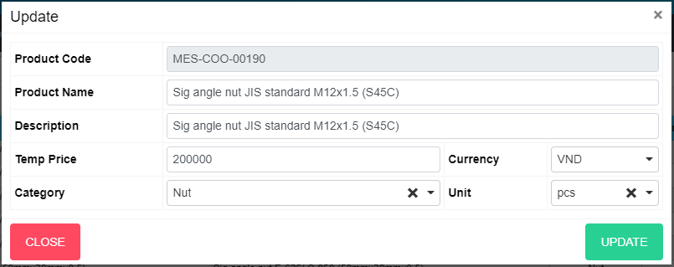

Edit equipment item’s info and click “UPDATE” button to update this item. If you want to cancel this work click “CLOSE” button.

### Delete Product Item

At the list page, click to “Delete” button

The modal for delete will be displayed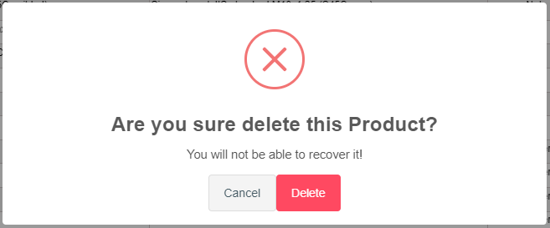

Click “DELETE” button to delete this Equipment Item. If you want to cancel this work click “Cancel” button.

## Purchase Request

### a. View PR list

To view PR list, click to “Orders” tab on the menu and click to “Purchase Request”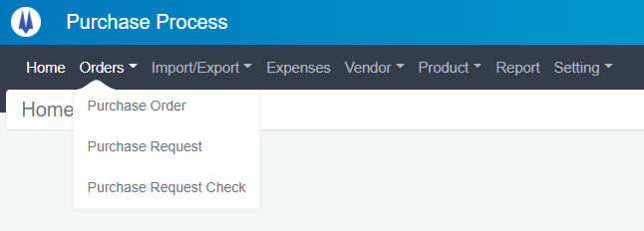

The PR list page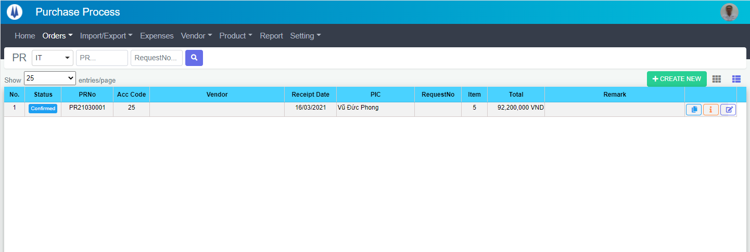

You can filter by Section, PRNo, RequestNo

### Create a new PR

Click to “Create New” button



A new modal will be displayed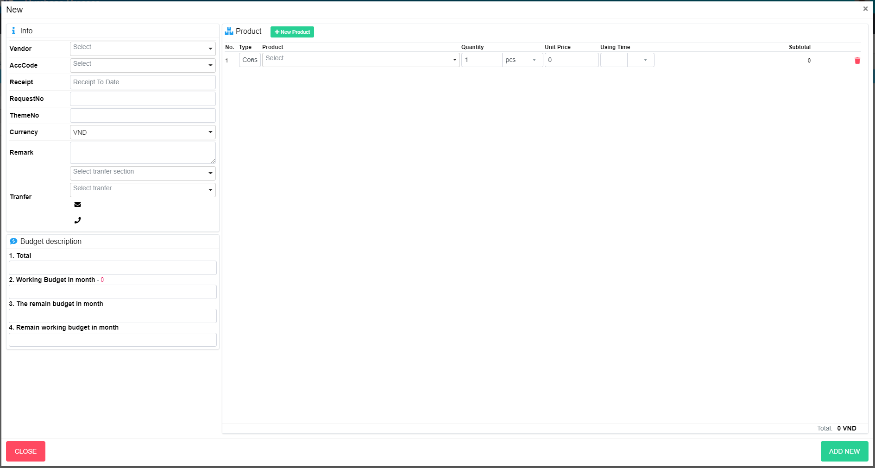

To remove product item, click to  button.

Input data and click “ADD NEW” button to create new PR. If you want to cancel this work click “CLOSE” button.

### Edit PR

At the list page, click to “Edit” button.

The modal for edit will be displayed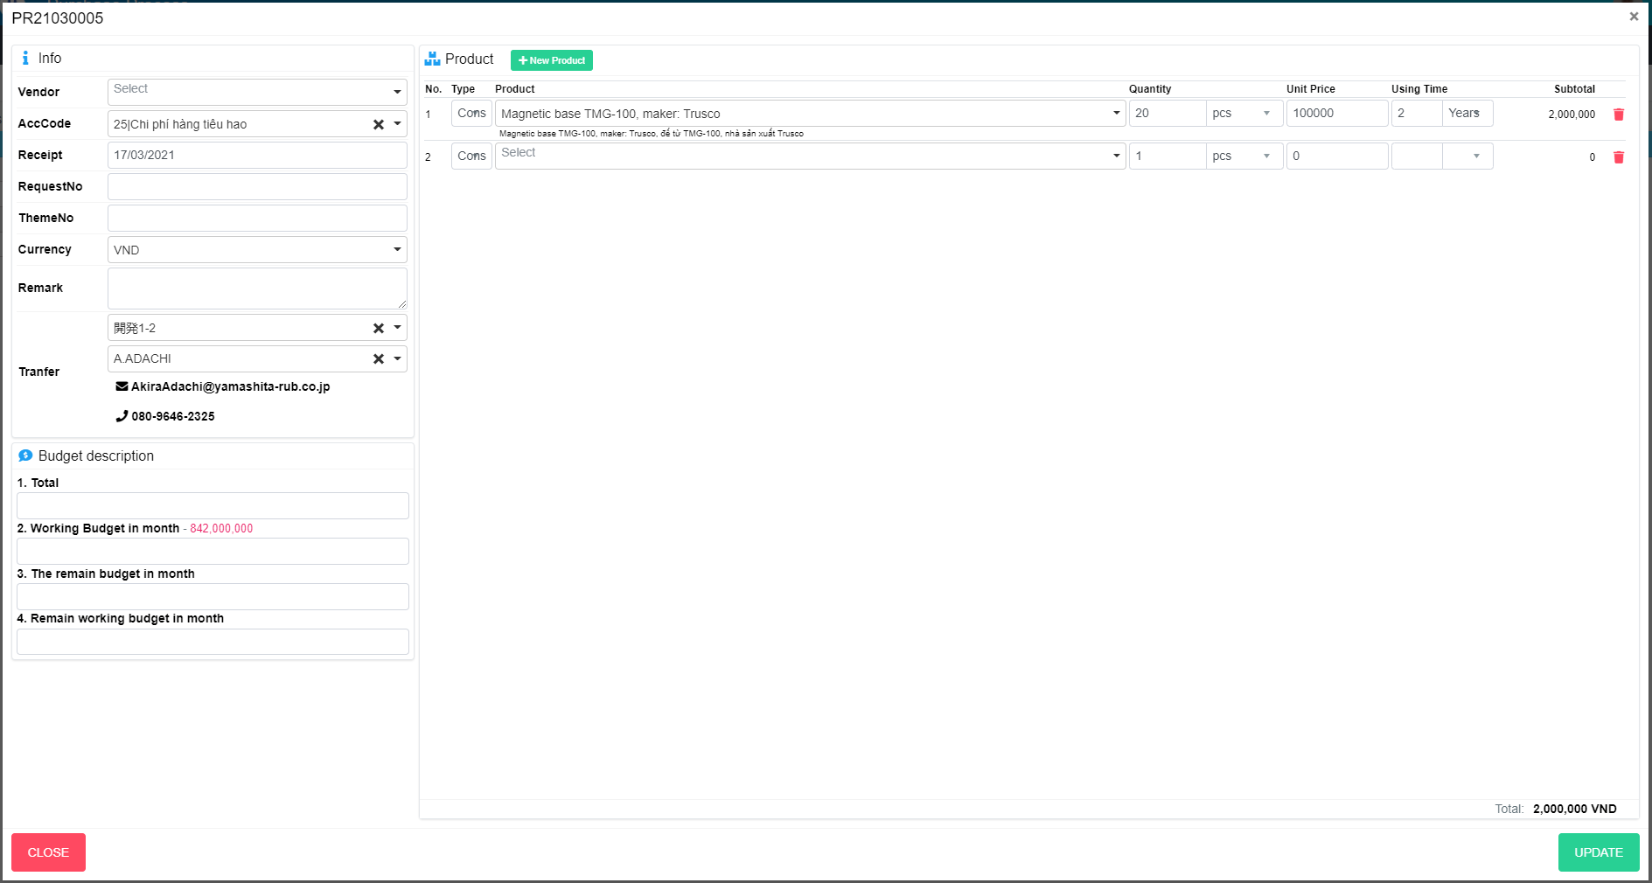

Edit PR’s info and click “UPDATE” button to update this item. If you want to cancel this work click “CLOSE” button.

### Clone PR

At the list page, click to “Clone” button.

A clone modal will be displayed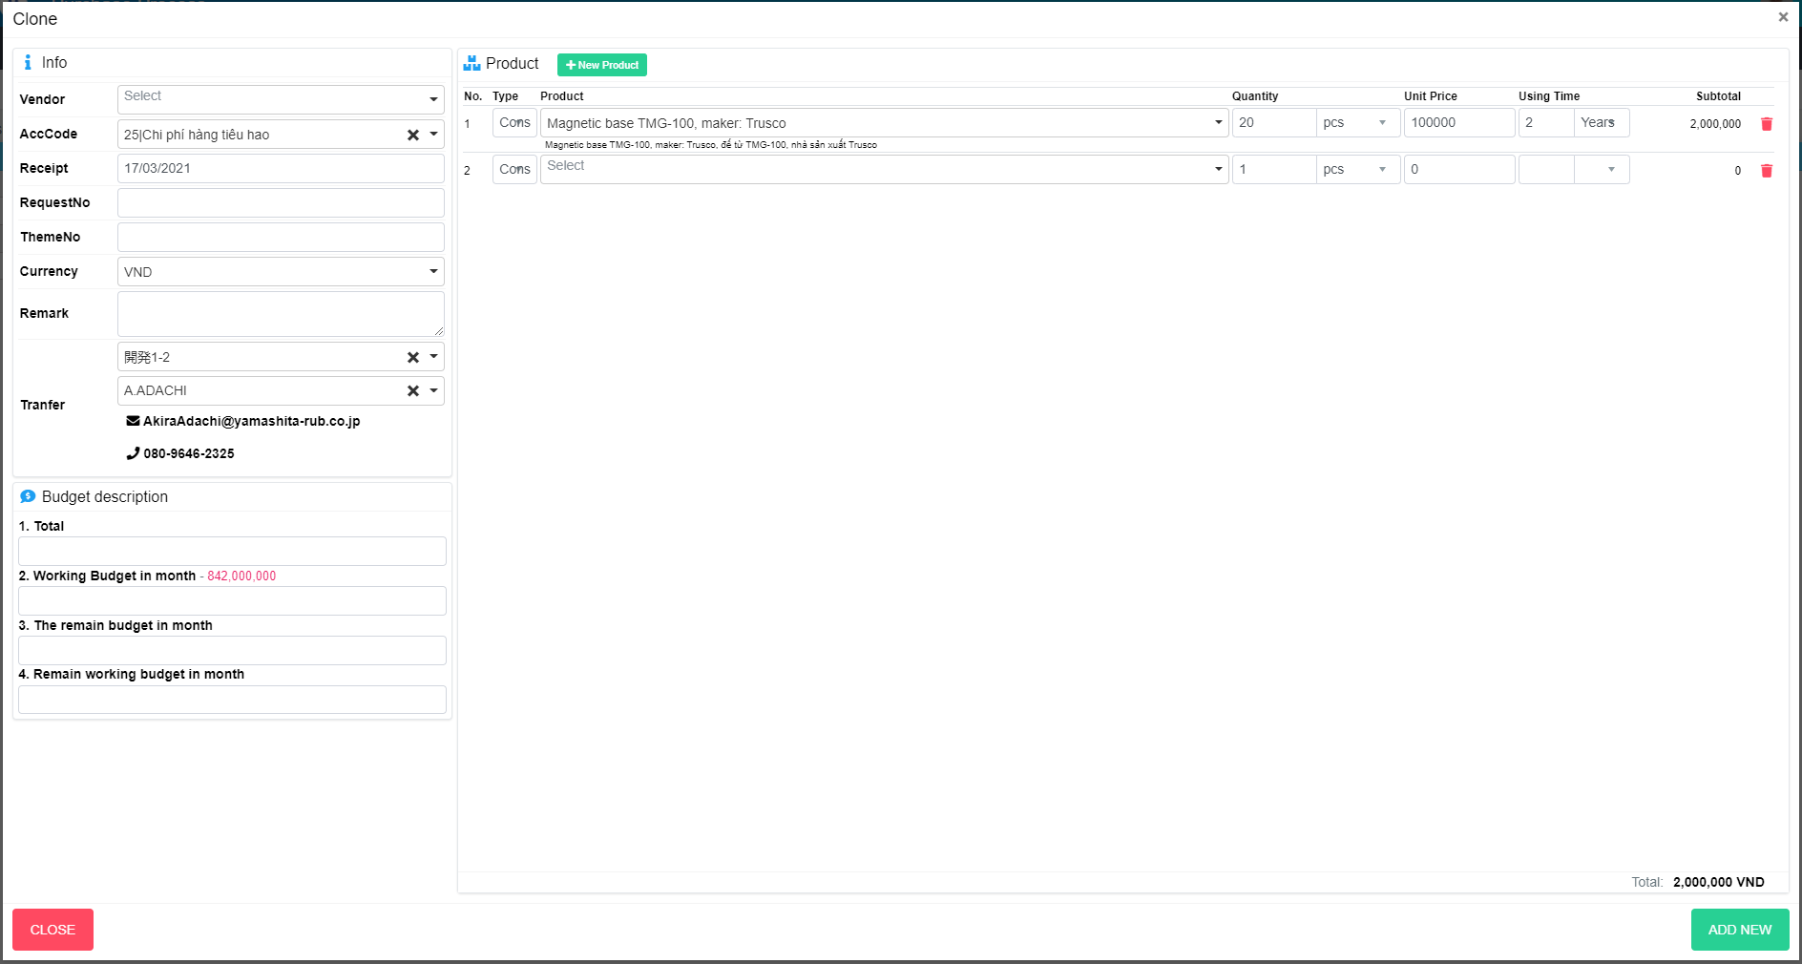

Input data and click “ADD NEW” button to create new PR. If you want to cancel this work click “CLOSE” button.

### Detail PR

At the list page, click to “Detail” button.

A detail modal will be displayed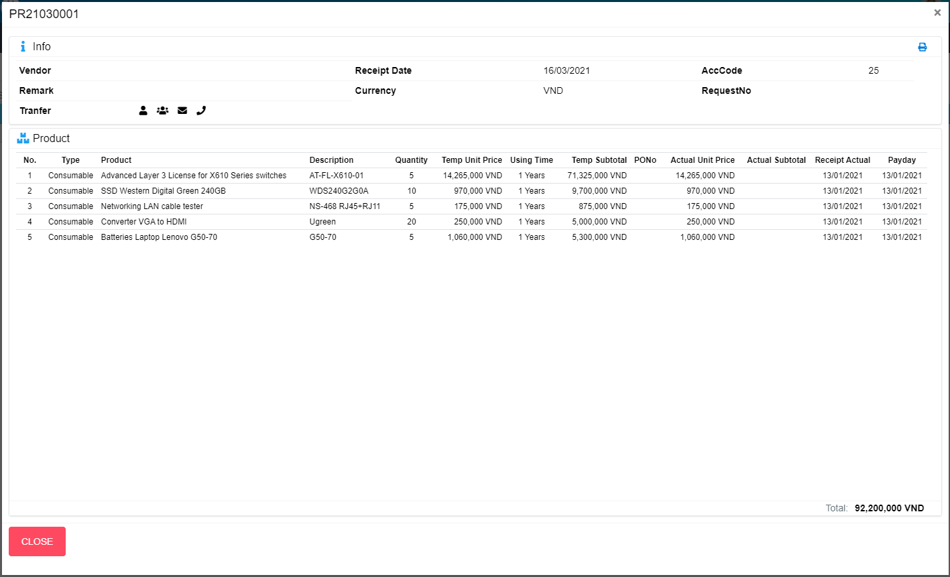

### Print PR

At the detail modal, click to “Print” button.

Print page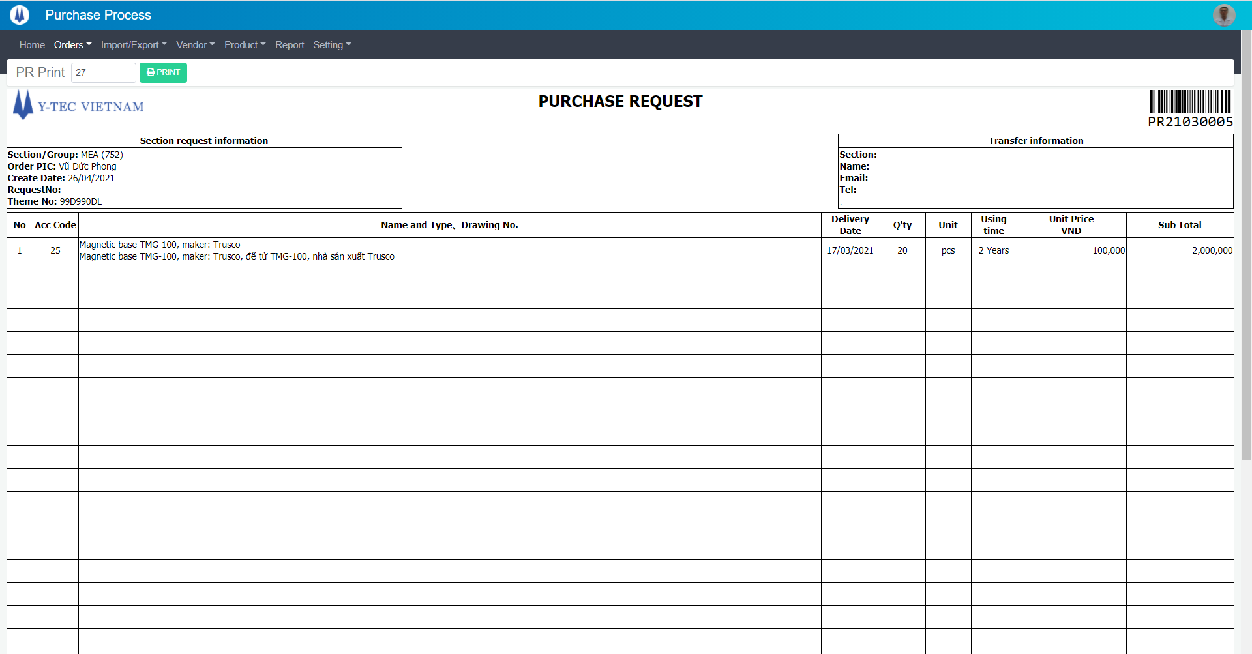

Click to “Print” button to print PR

## Export Request

## ER List:

In menu click to “Import/Export”, choose “Export Request”

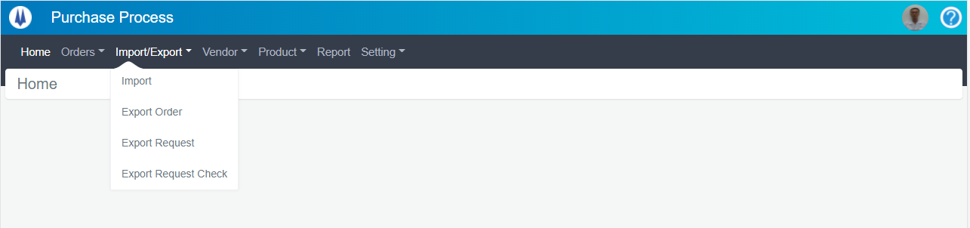

Export Request List will show as below:

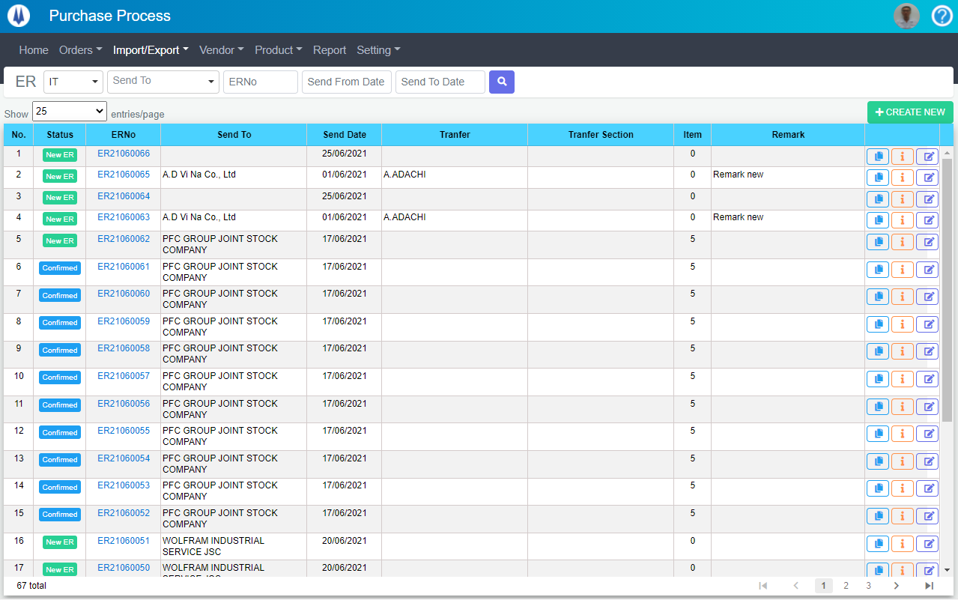

Open “EditER” popup

Open “ERDetail” popup

Open “CloneER” popup

Open “AddNewER” popup

Change page of List

Search item by highlight fields

Select display rows per page

### Create New ER:

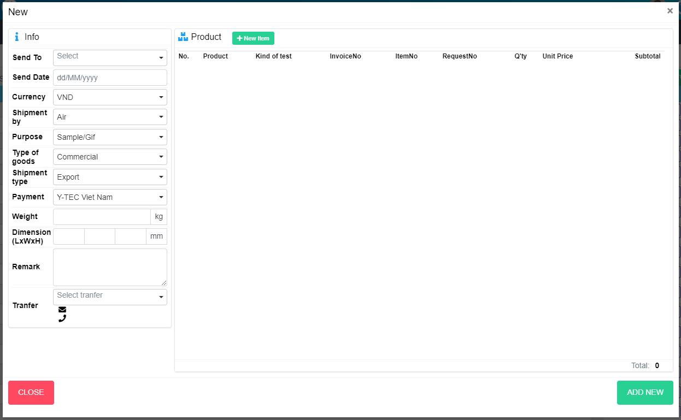

Create New ER

Close popup Create New ER

Add one more item

### Update ER

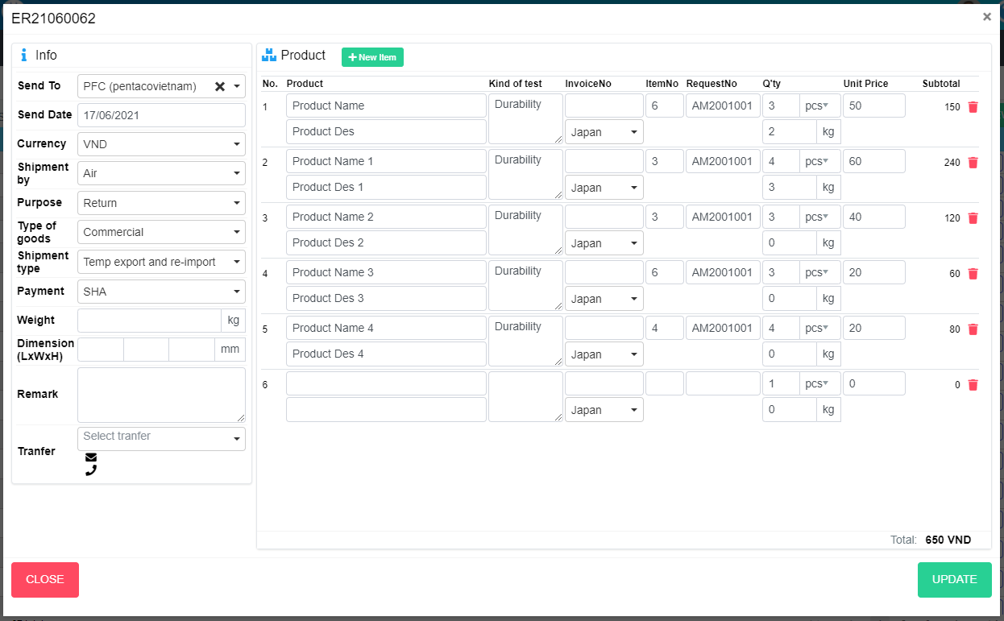

Close popup Update ER

Remove item

Add one more item

Update ER

### Clone ER

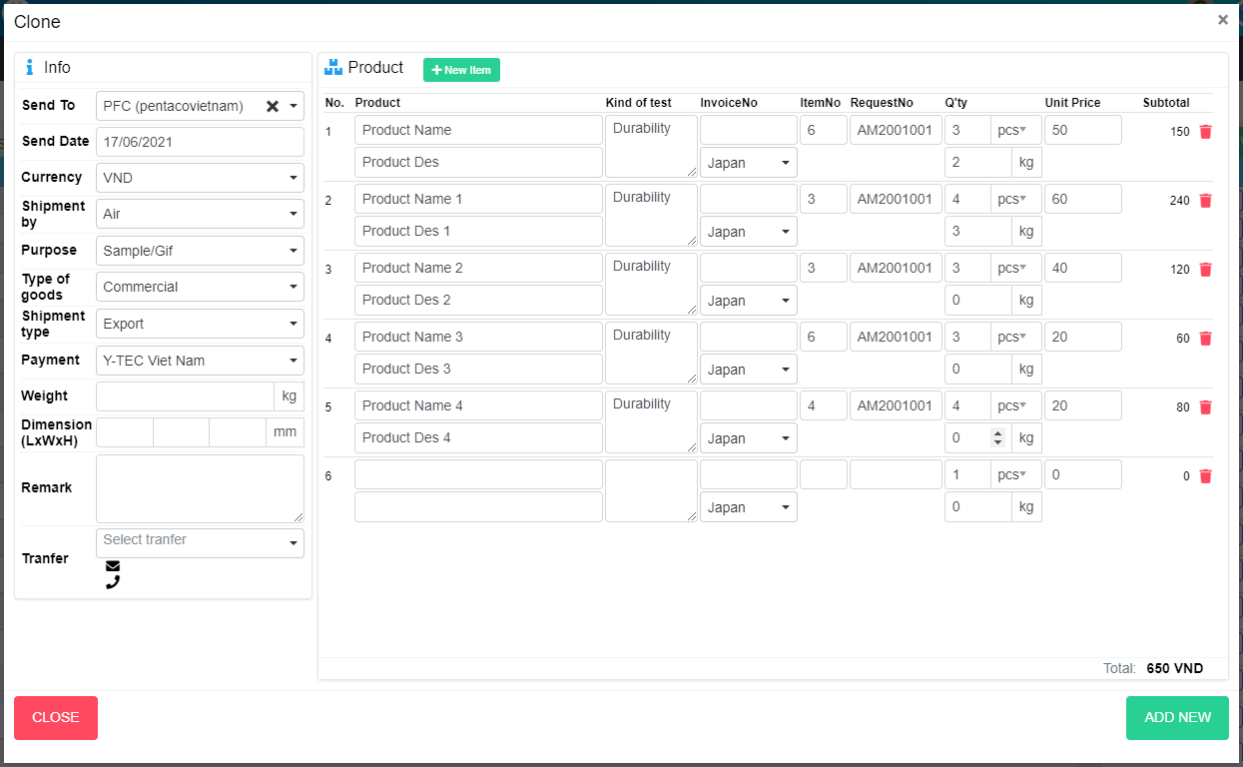

Close popup Clone ER

Add New ER

Add one more item

Remove item

### Detail ER

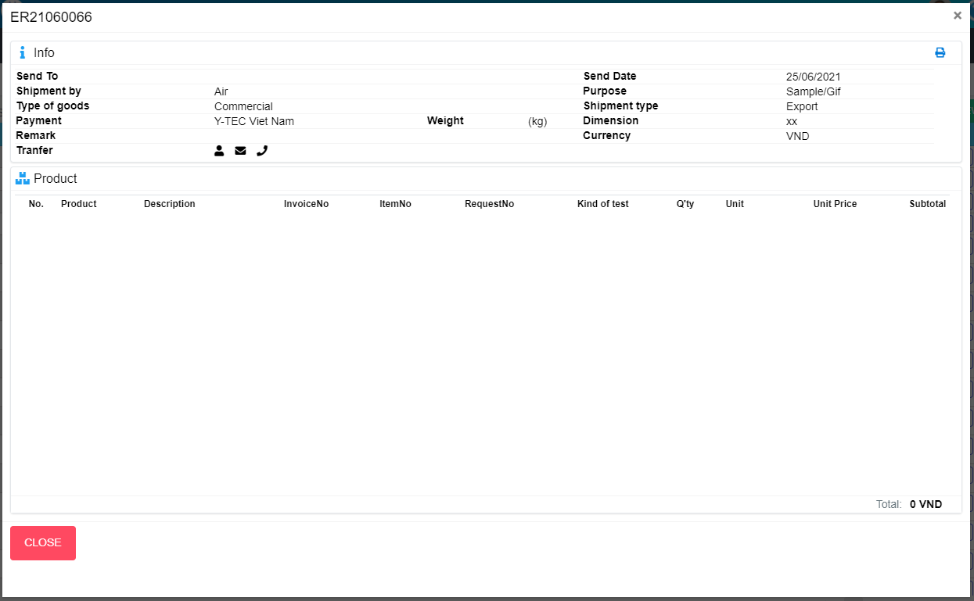

Open Print ER screen

Close popup Detail ER

### Print ER

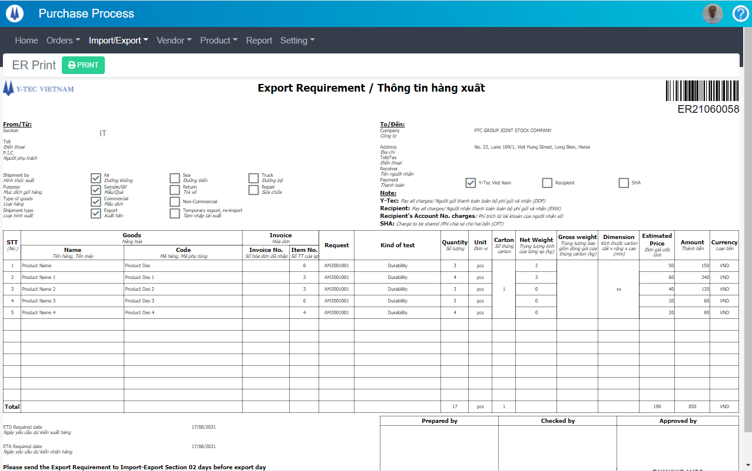

Print ER

# For PP Group

## Login

Go to internal website and click to “Equipment” icon:



After login into system

## Unit

### View Unit list

Click to “Setting” menu and click to “Unit”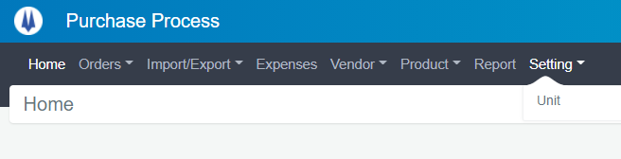

Unit list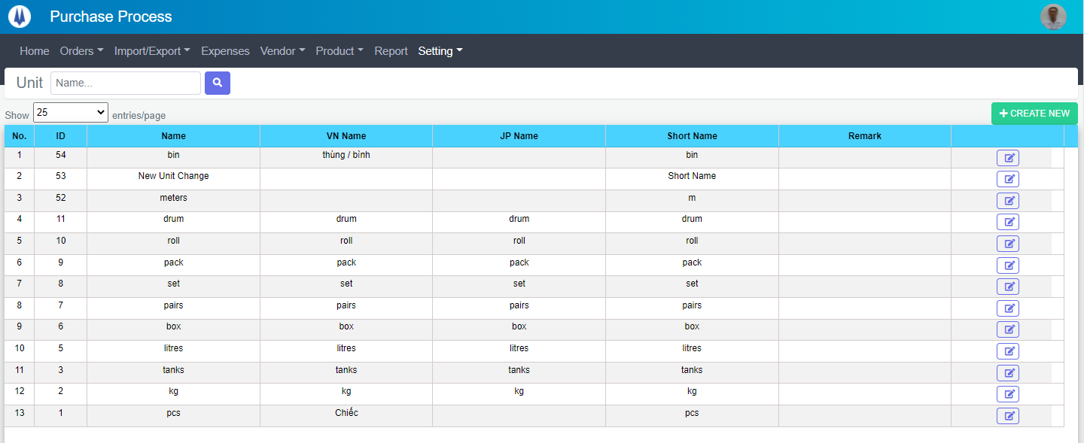

You can filter by Unit Name

### Create new Unit

Click to “Create New” button

A new modal will be displayed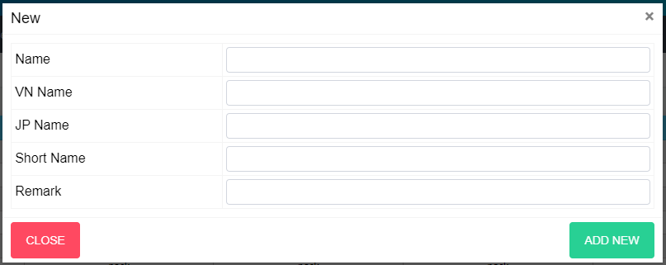Input data and click “ADD NEW” button to create new Unit. If you want to cancel this work click “CLOSE” button.

### Edit Unit

At the Unit list page, click to “Edit” button

The modal for edit will be displayed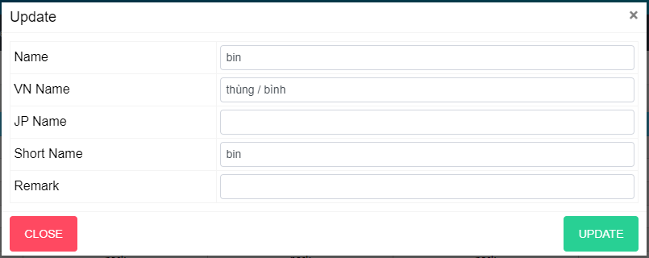Edit Unit’s info and click “UPDATE” button to update this category. If you want to cancel this work click “CLOSE” button.

## Vendor

### View Unit list

Click to “Vendor” menu and click to “Vendor”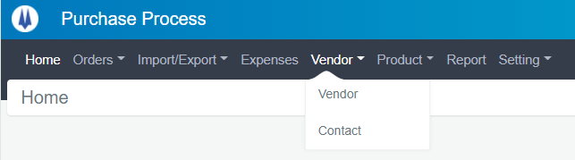

Unit list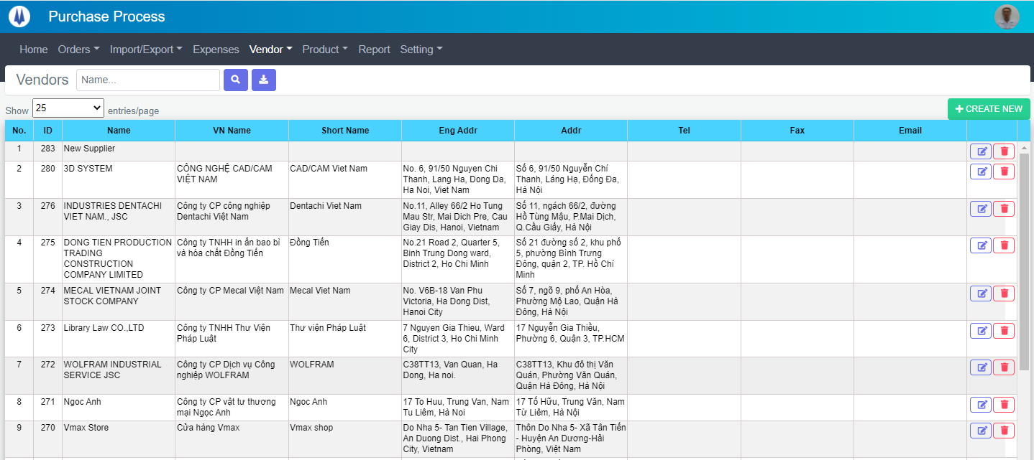

You can filter by Vendor name

### Create new Vendor

Click to “Create New” button

A new modal will be displayed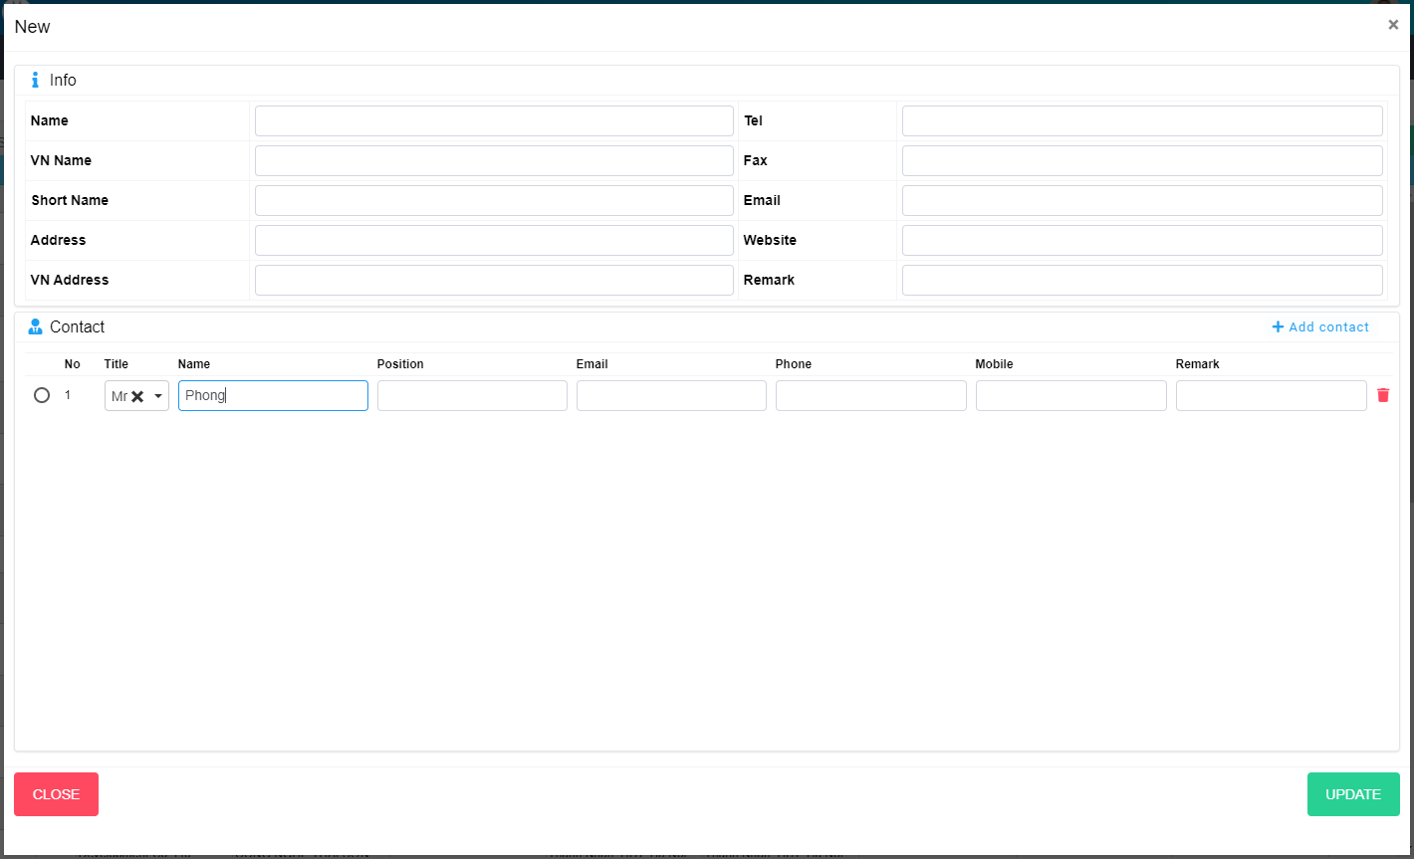

To add new contact click to “Add contact” button.

To remove contact click to “Remove” button

Input data and click “ADD NEW” button to create new Vendor. If you want to cancel this work click “CLOSE” button.

### Edit Vendor

At the Unit list page, click to “Edit” button

The modal for edit will be displayed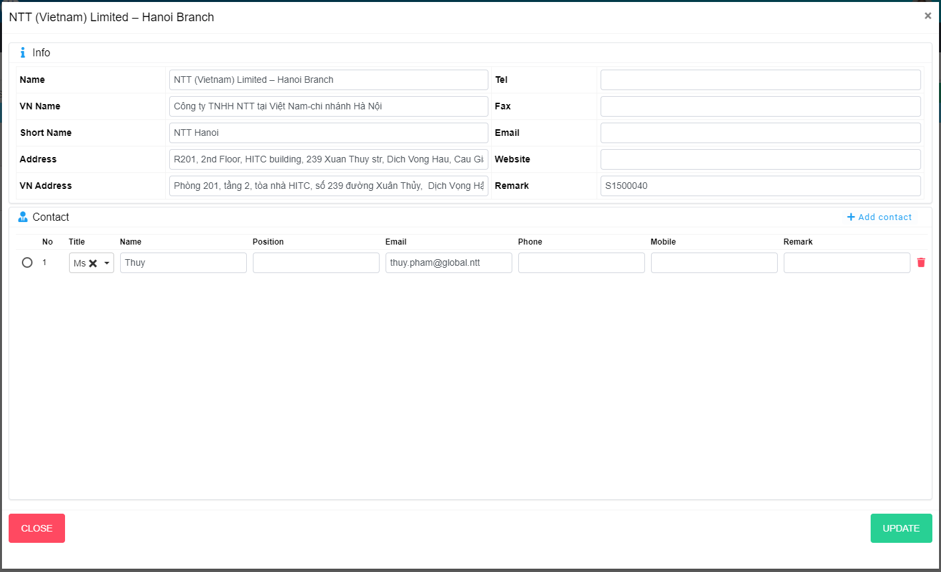Edit Unit’s info and click “UPDATE” button to update this vendor. If you want to cancel this work click “CLOSE” button.

### Delete Vendor

At the list page, click to “Delete” button

The modal for delete will be displayed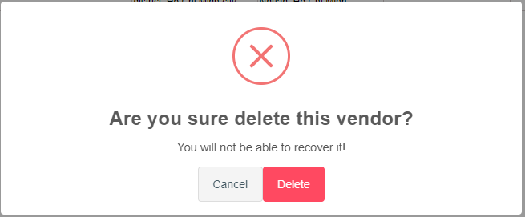Click “DELETE” button to delete this Vendor. If you want to cancel this work click “Cancel” button.

## PR Check

### View Unit list

Click to “Vendor” menu and click to “Vendor”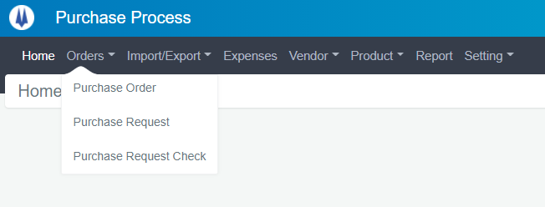

Purchase Request list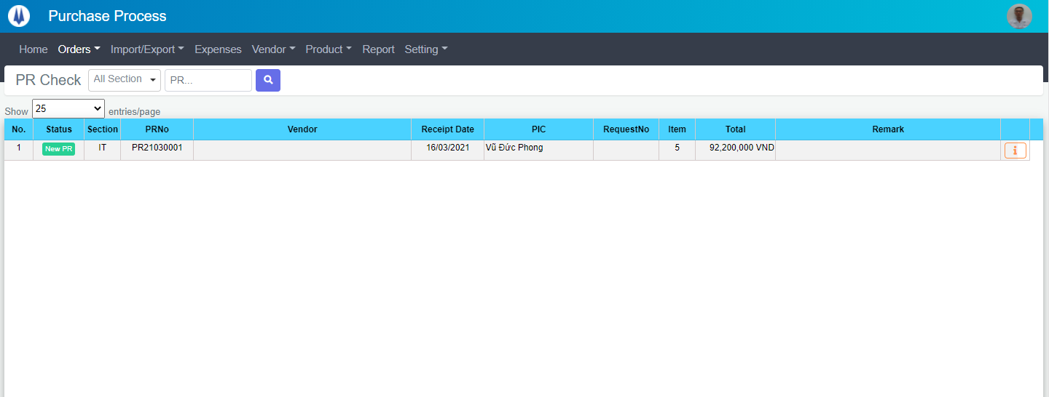

You can filter by Section, PRNo

### Confirm PR

In PR Check list page click to “Detail” button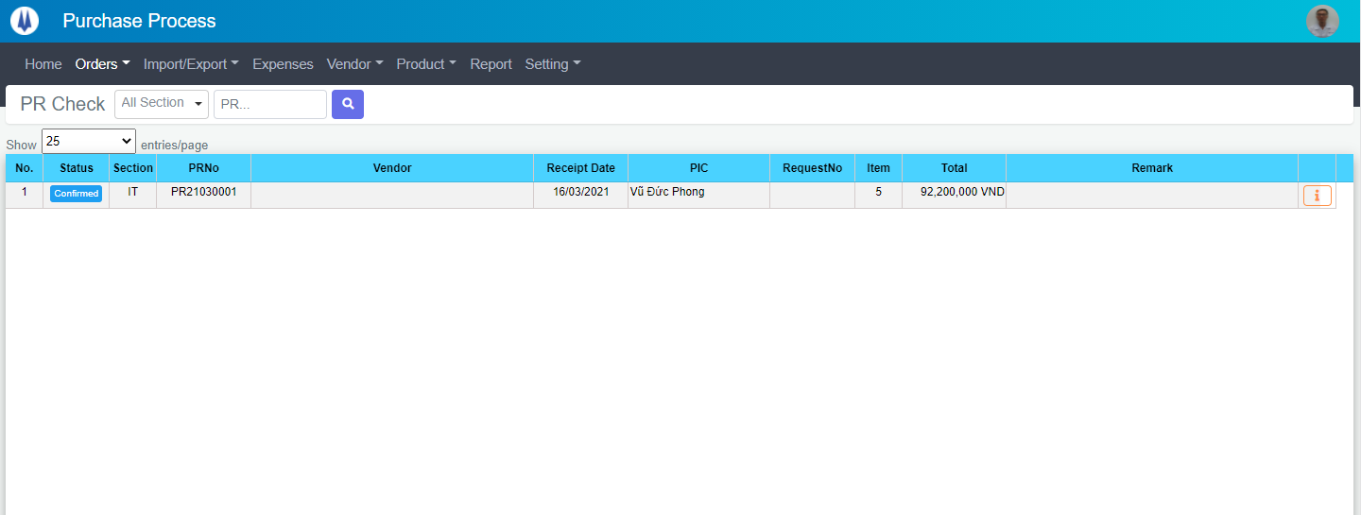

A detail modal will be displayed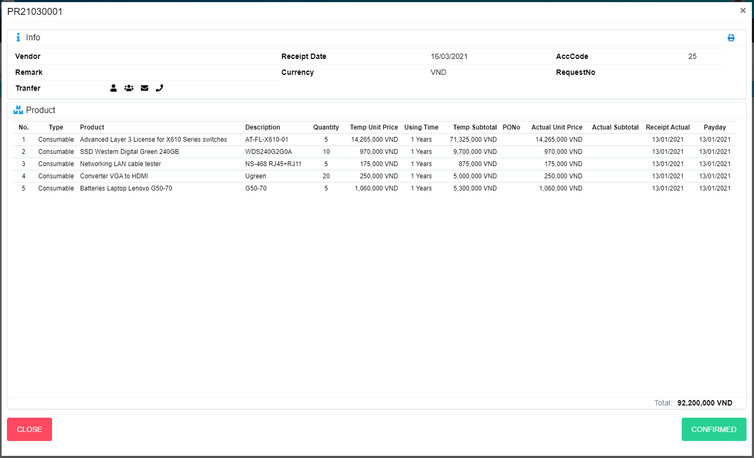

Click “CONFIRMED” button to confirm this PR. If you want to cancel this work click “CLOSE” button.

### Return PR

In PR Check list page click to “Detail” button

The detail modal will be displayed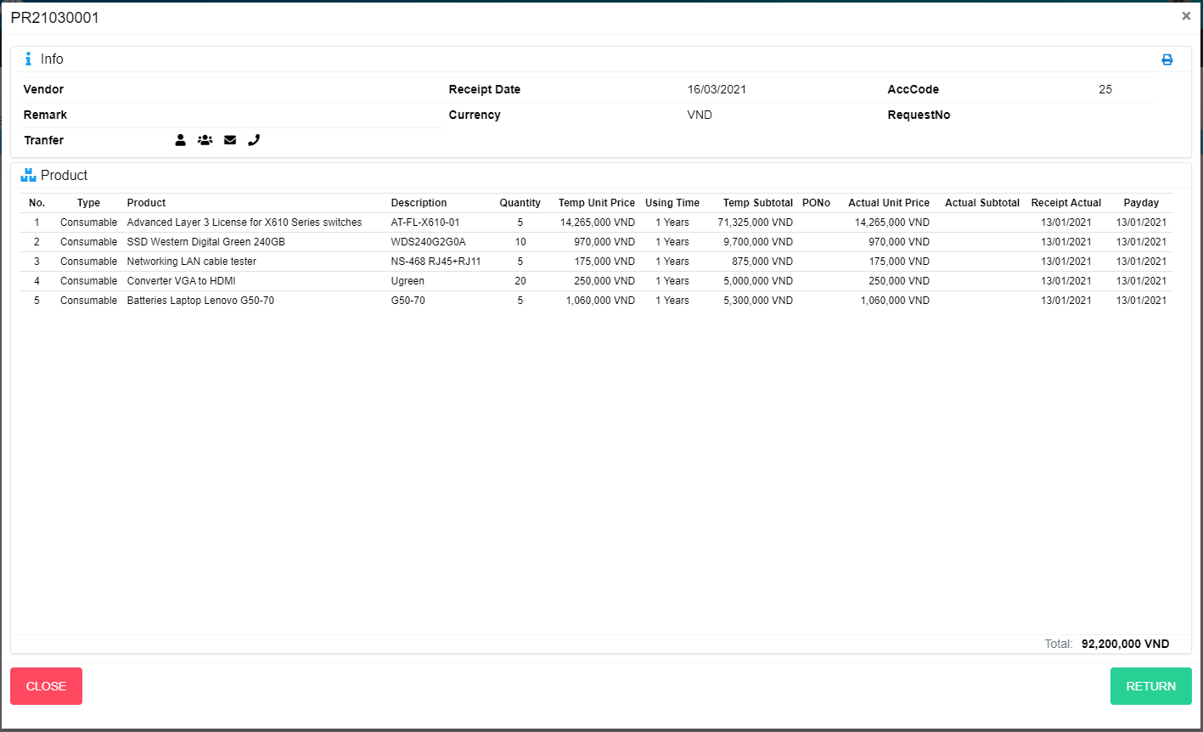

Click “RETURN” button to confirm this PR. If you want to cancel this work click “CLOSE” button.

## Purchase Order Item List

### View PO Item list

Click to “Vendor” menu and click to “Vendor”

Purchase Order Item list 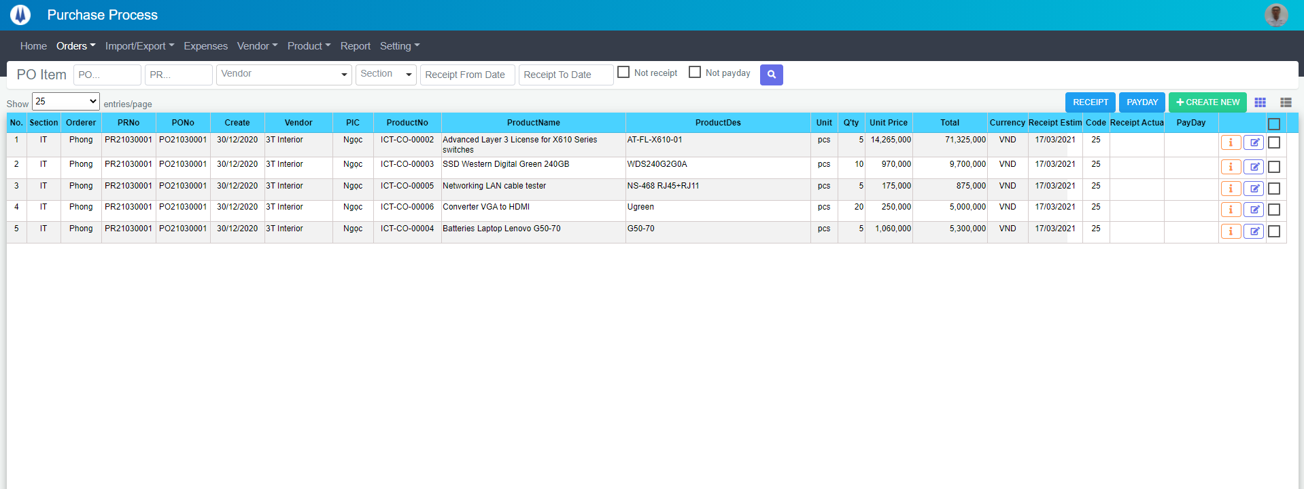

You can filter by PONo, PRNo, Vendor, Section, Receipt From Date, Receipt To Date, Not Receipt, Not Payday

### Create new PO

In PO list page click to “Create New” button

A modal will be displayed 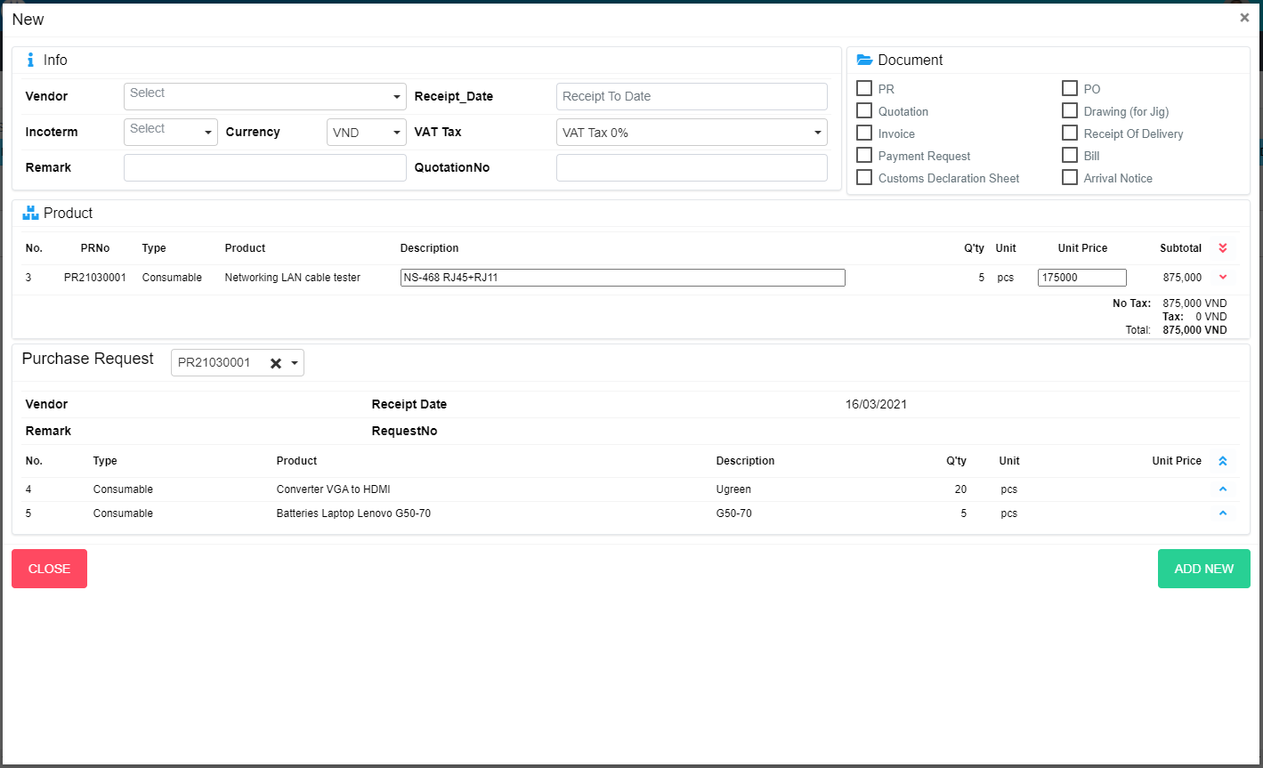

Click button  to add move all item from PR to PO

Click button  to add item from PR to PO

Click button  to remove all item from PO

Click button  to remove item from PO

Input data and click “ADD NEW” button to create new PO. If you want to cancel this work click “CLOSE” button.

### Edit PO

In PO list page click to “Update” button

The modal will be displayed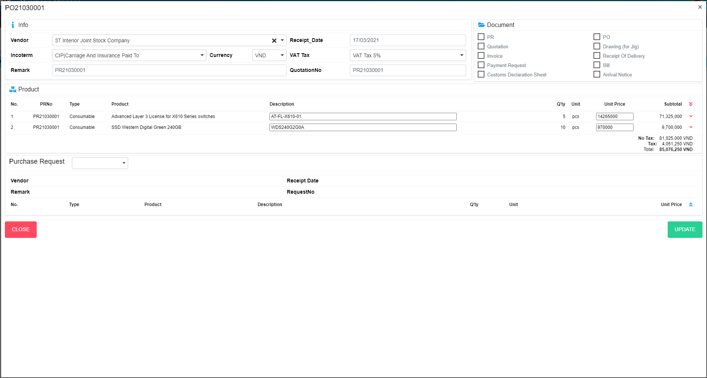

Edit PO’s info and click “UPDATE” button to update this PO. If you want to cancel this work click “CLOSE” button.

### Detail PO

In PO list page click to “Update” button

The modal will be displayed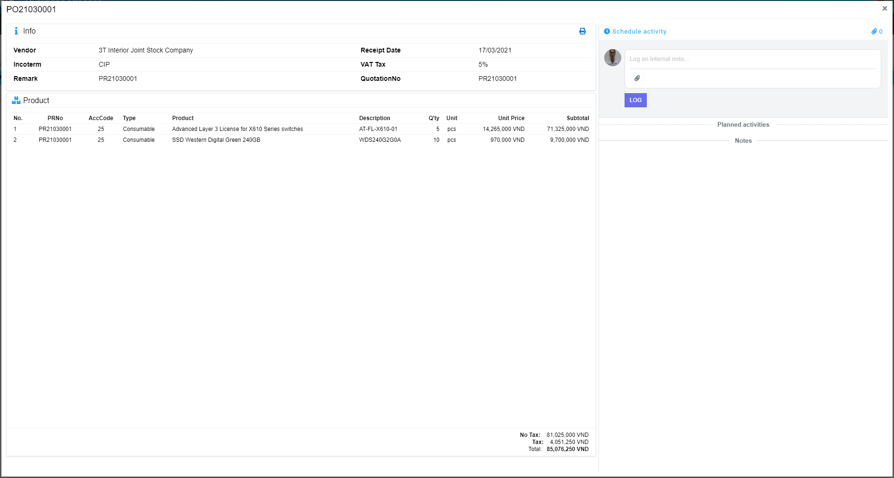

* Create new log

Input content to Log and internal note input, choose file and click “LOG” button

* Add new activity

In detail modal click to “Schedule activity”” button

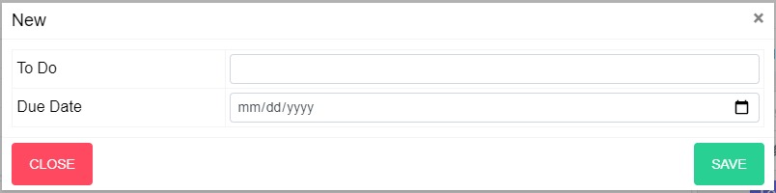

Input info and click to “SAVE” button to create new activity

* Edit activity

In detail modal click to “EDIT” button

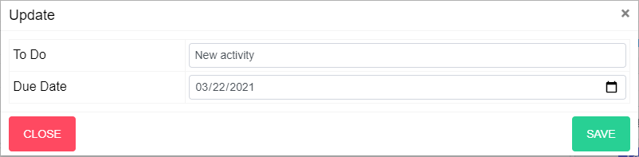

Update and click “SAVE” button to edit activity

* Mark Done activity

In detail modal click to “Mark Done” button

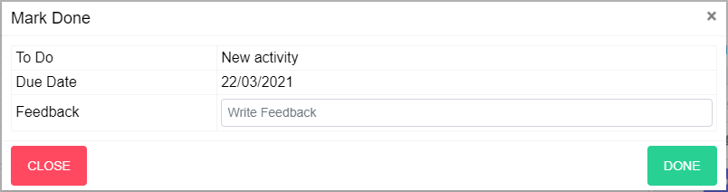

Update and click “DONE” button to finish activity

* Cancel activity

In detail modal click to “CANCEL” button

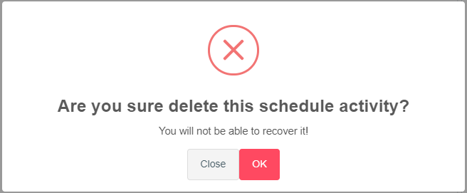

Click “OK” button to Cancel schedule activity

### Payday

In PO Item check item and click “PAYDAY” button

The modal will be displayed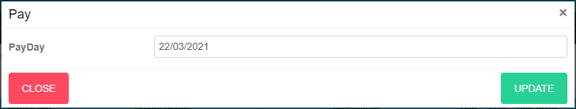

Input data and click “UPDATE” button to update payday. If you want to cancel this work click “CLOSE” button.

### Receipt

In PO Item check item and click “RECEIPT” button

The modal will be displayed 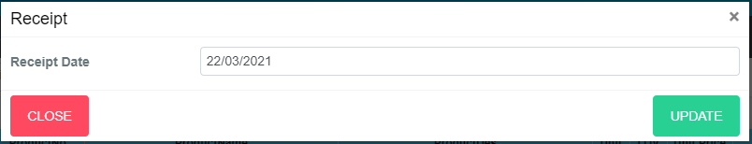

Input data and click “UPDATE” button to update receipt day. If you want to cancel this work click “CLOSE” button.

### Print PO

At the detail modal, click to “Print” button. 

Print page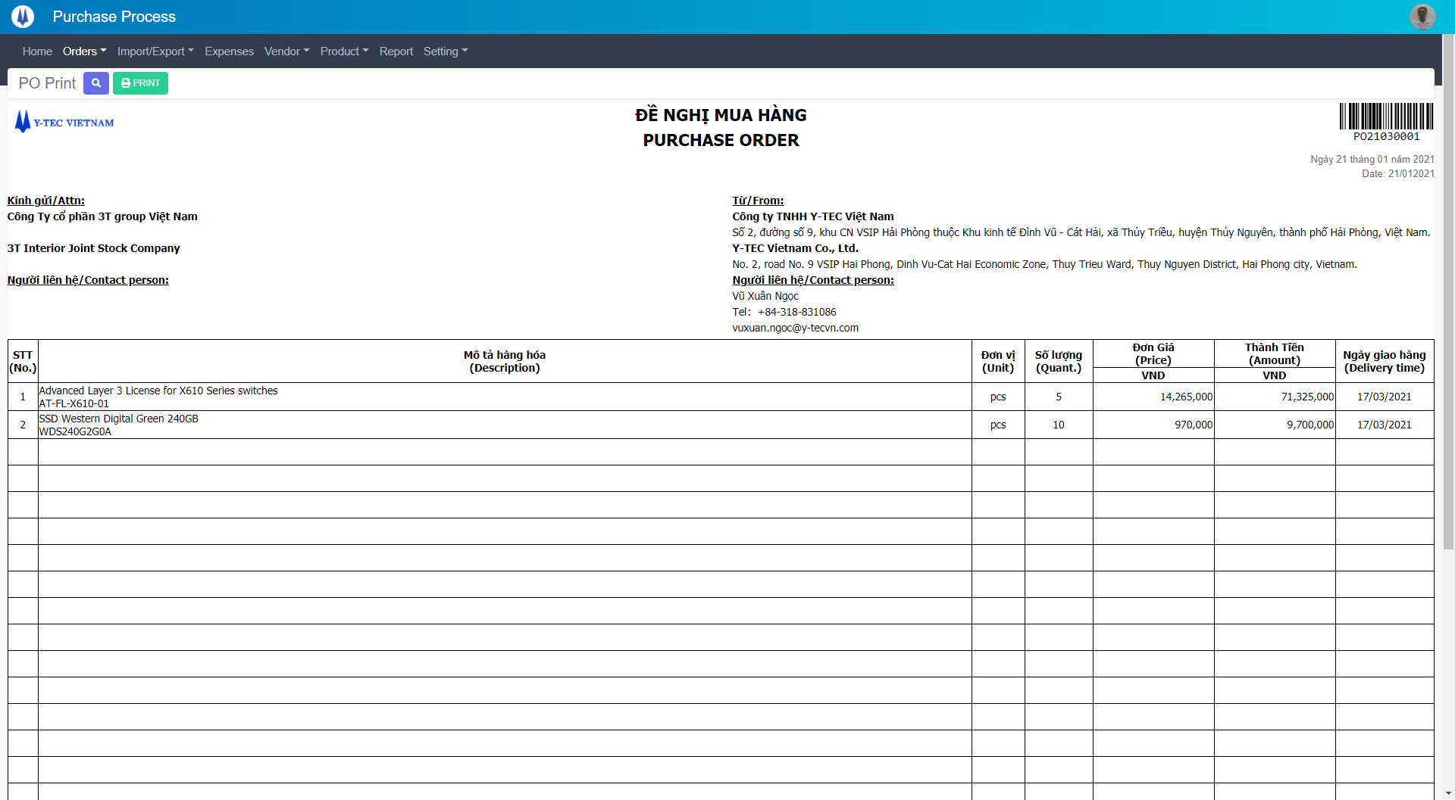

Click to “Print” button to print PO

## Export Request Check

### Export Request Check list:

In menu click to “Import/Export”, choose “Export Request Check”Export Request Check List will show as below:

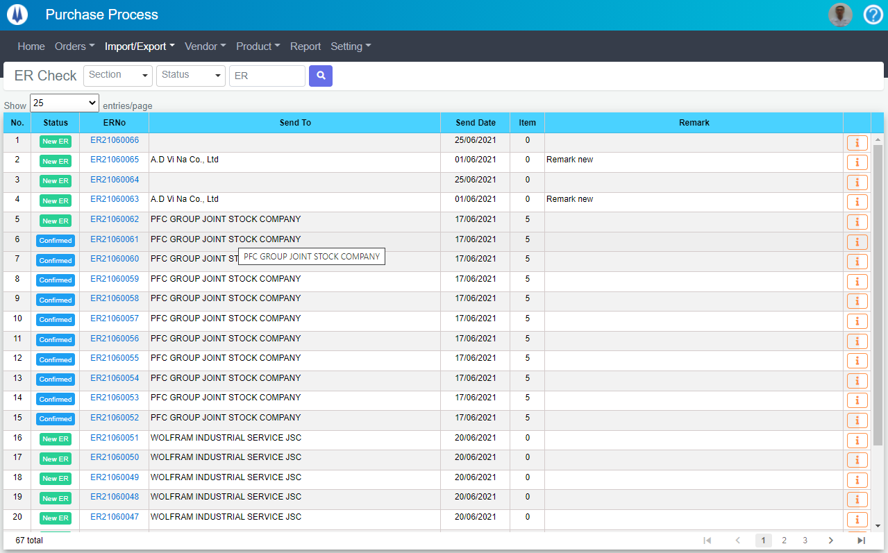

Open “ERDetail” popup

Select display rows per page

Search item by highlight fields

Change page of List

### ER detail

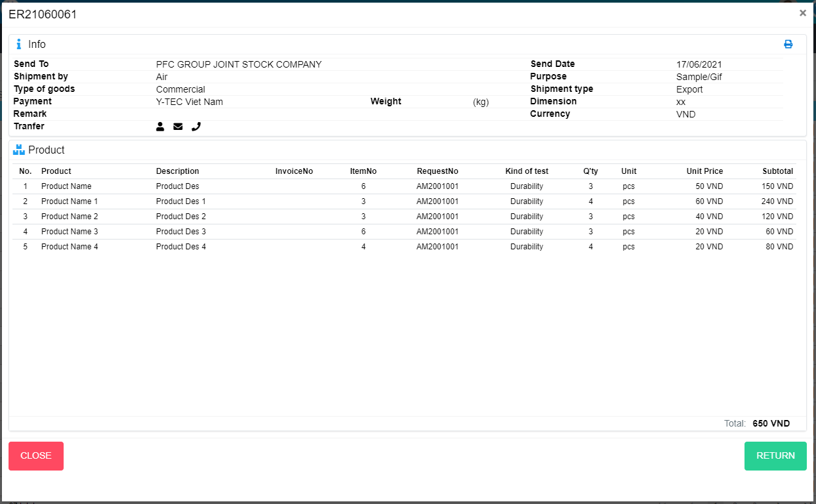

Return ER

Close popup Detail ER

## Export Order

### Export Order list:

In menu click to “Import/Export”, choose “Export Order”Export Order List will show as below:

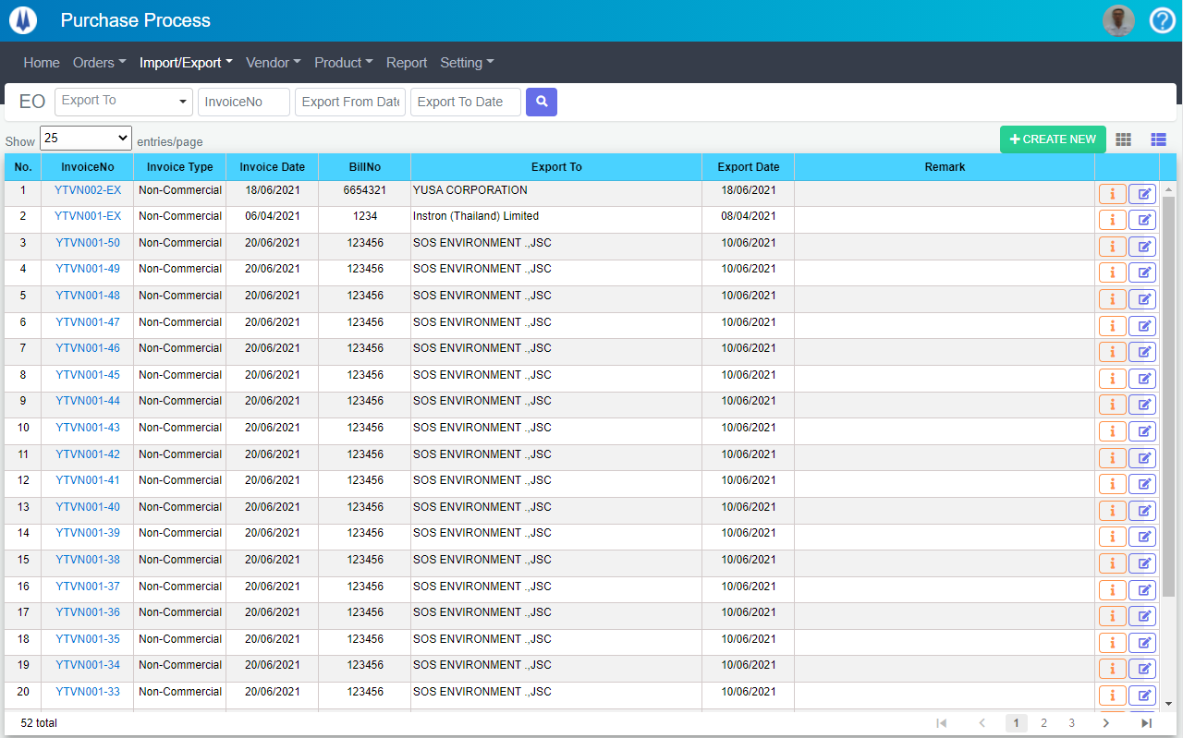

Open “EODetail” popup

Open “EditEO” popup

Open “EOItemList” popup

Open “AddNewEO” popup

Search item by highlight fields

Change page of List

Select display rows per page

### Export Order create:

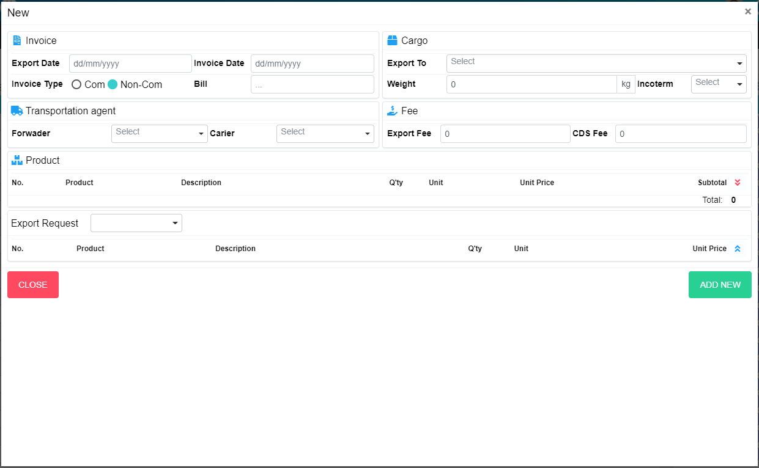

Create New EO

Close popup Create New EO

Select ER

### Export Order edit:

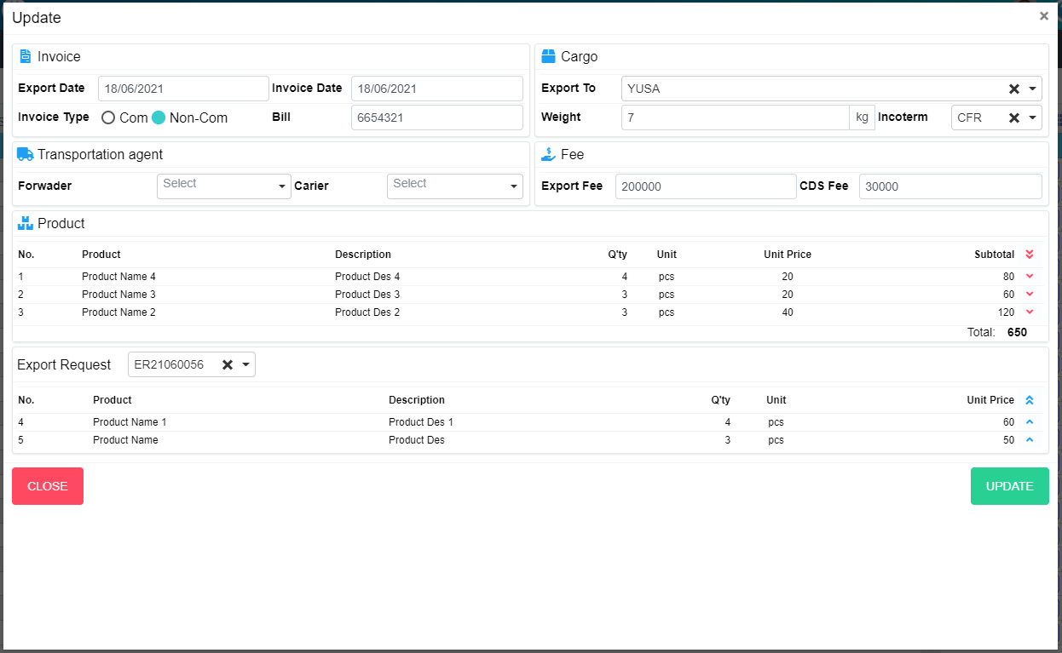

Move item from ER list to product list

Move all item from ER list to product list

Move item from product list to ER list

Move all item from product list to ER list

Select ER

Update EO

Close popup Update EO

### Export Order Detail:

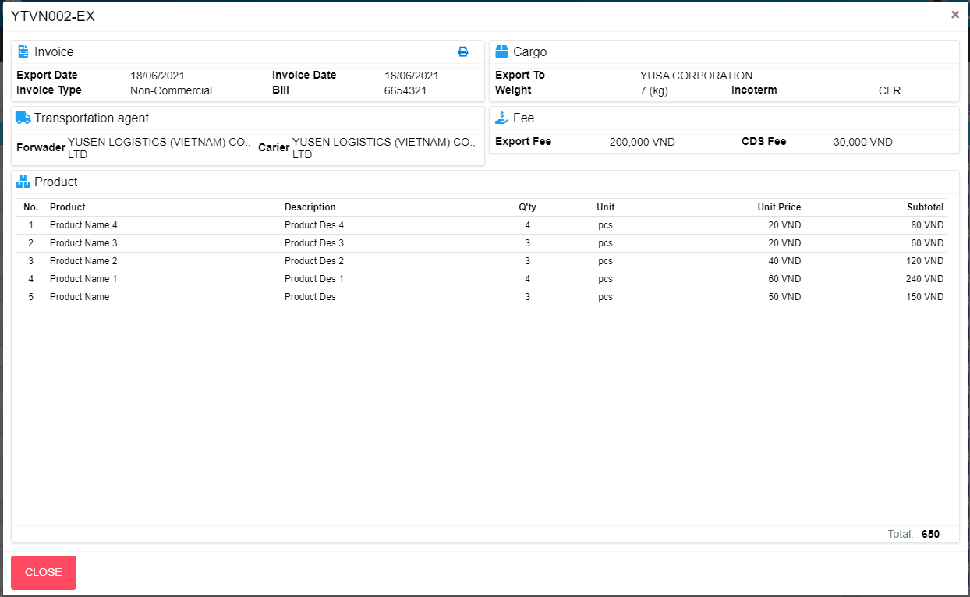

Print EO

Close popup Detail EO

### Export Order Item list:

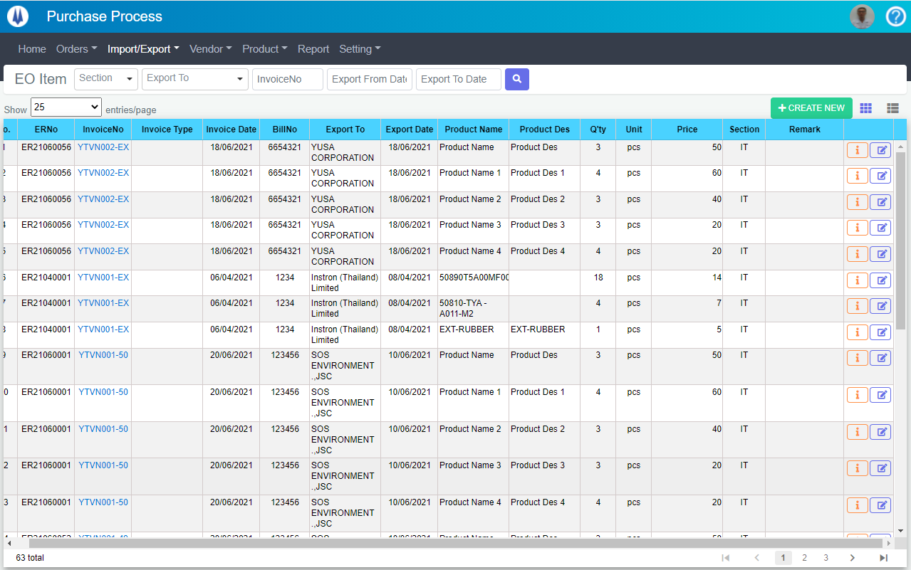

Search item by highlight fields

Open “EOList” popup

Open “EditEO” popup

Open “EODetail” popup

Open “AddNewEO” popup

Change page of List

Select display rows per page

## Import

### Import list:

In menu click to “Import/Export”, choose “Import”Import List will show as below: 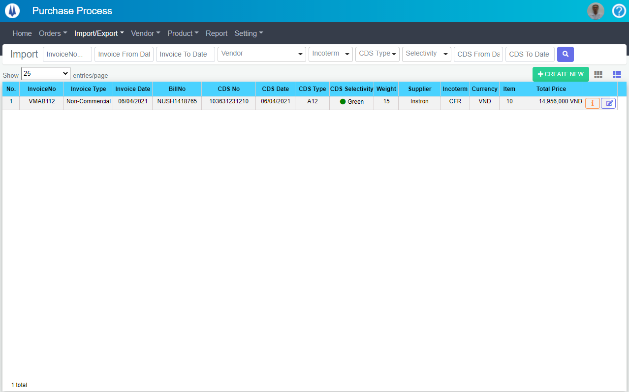

Open “EditImport” popup

Open “ImportDetail” popup

Open “AddNewImport” popup

Search item by highlight fields

Open “ImportItemList” popup

Select display rows per page

### Create new Import:

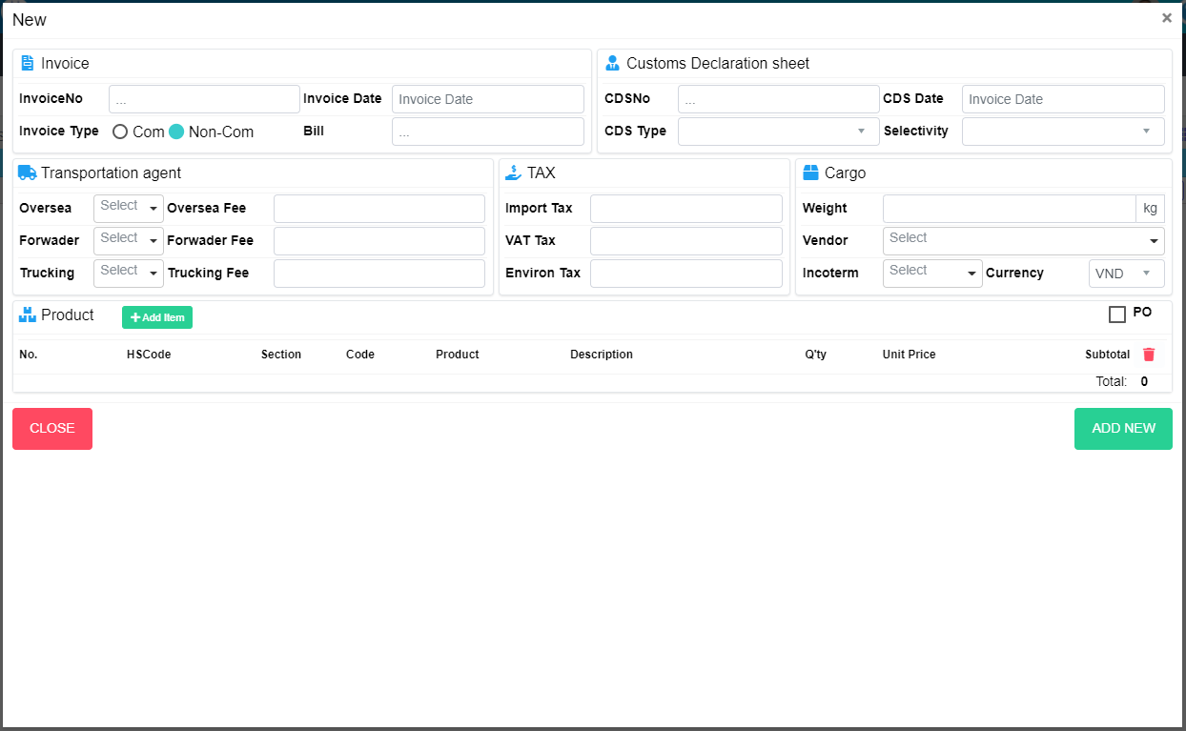

Change “Use PO” screen

Add new item

Create New Import

Close popup Create New Import

### Create new Import:

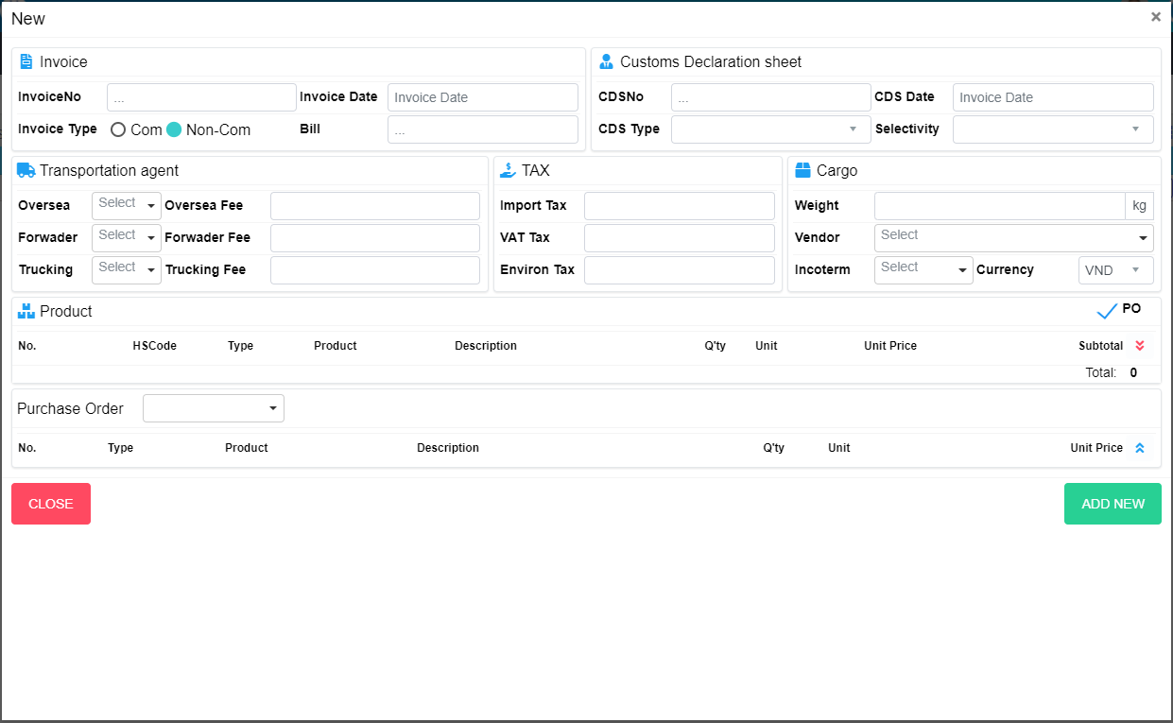

Select PO

Change “No Use PO” screen

Close popup Create New Import

Create New Import

### Update Import:

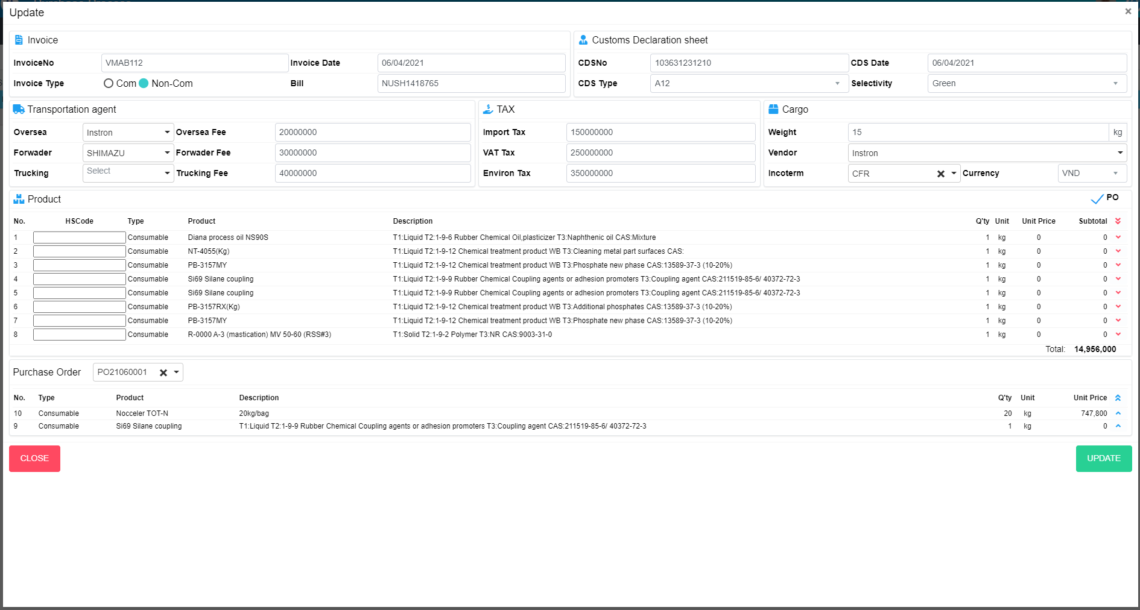

Close popup Create New Import

Create New Import

Change “No Use PO” screen

Select PO

### Detail Import:

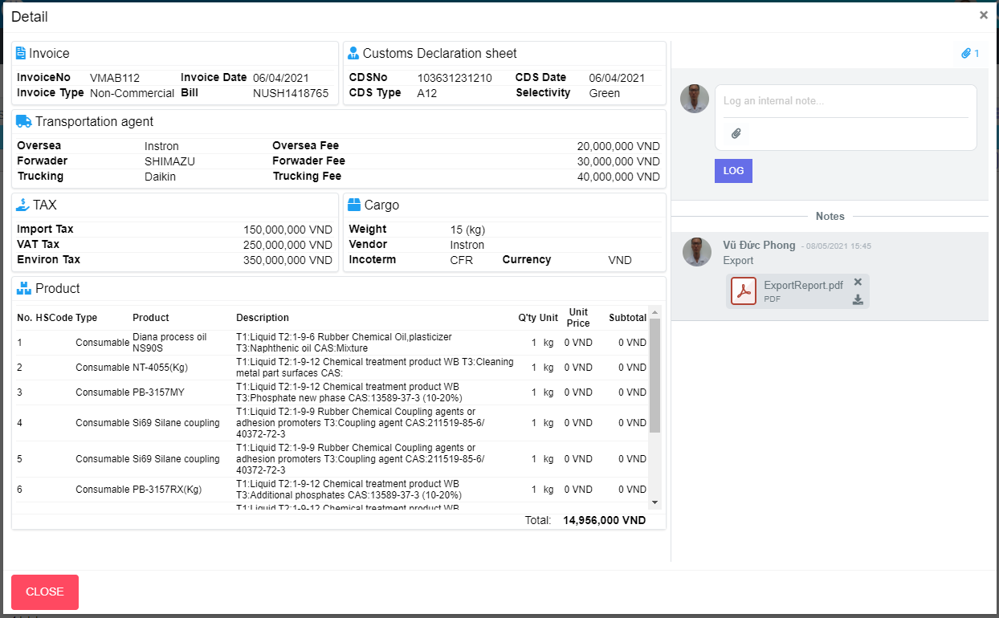

Download file

Remove file

Log

Choose file to upload

Show/Hide attach list

Close popup Detail Import

### Import Item list:

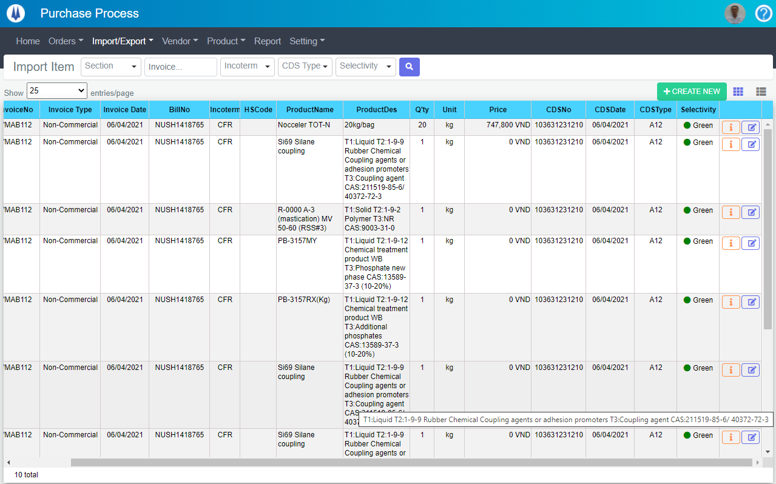

Open “ImportList” popup

Search item by highlight fields

Open “AddNewImport” popup

Open “EditImport” popup

Open “ImportDetail” popup

Select display rows per page

## Vendor claim:

### Export Order list:

In menu click to “Vendor”, choose “Import”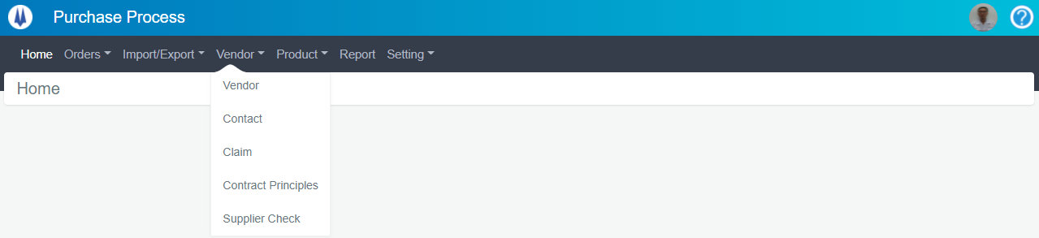

Import List will show as below: 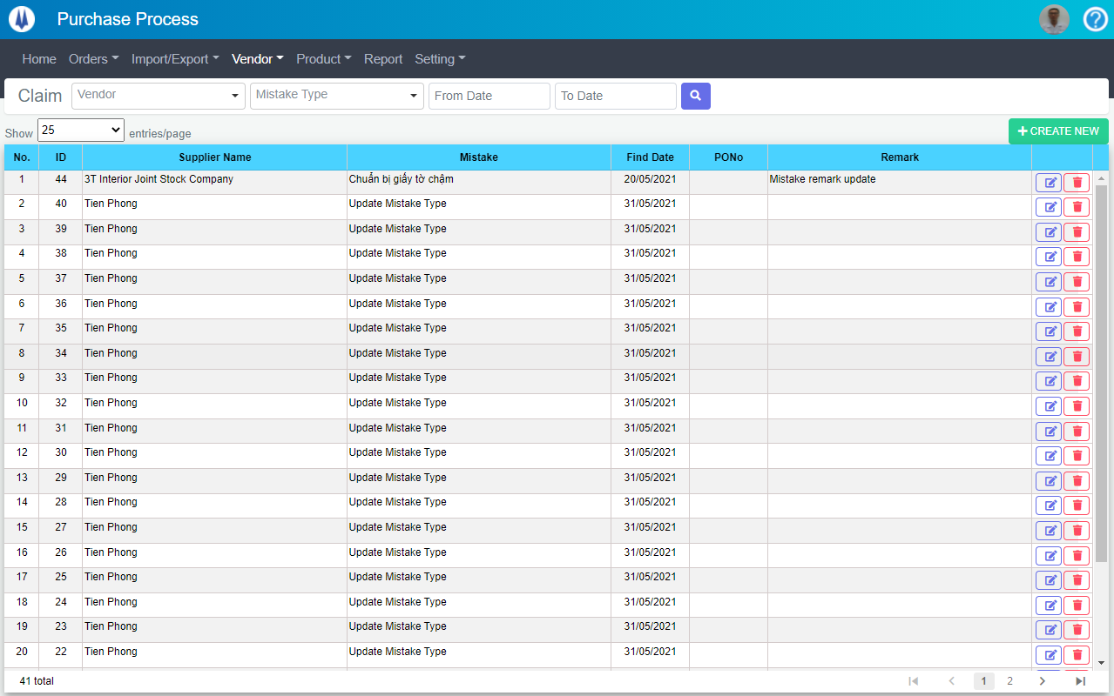

Open “DeleteContract” popup

Open “AddNewClaim” popup

Search item by highlight fields

Open “EditClaim” popup

Change page of List

Select display rows per page

### Create new Claim:

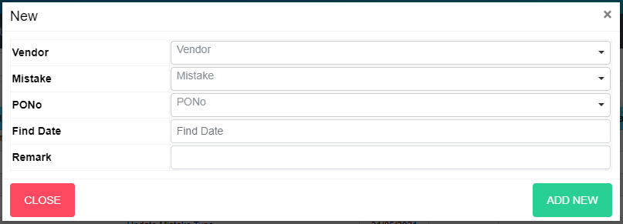

Create New Claim

Close popup Create New Claim

### Edit Claim:

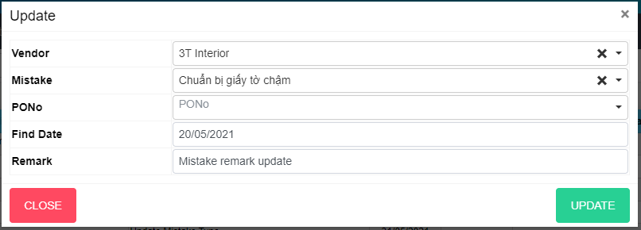

Close popup Edit Claim

Update Claim

### Edit Claim

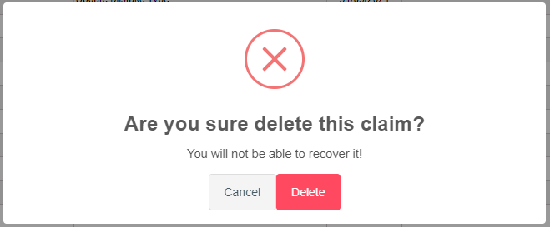

Delete Claim

Close popup Delete Claim

## Contract Principles:

### Contract Principles list:

In menu click to “Vendor”, choose “Contract Principles”

Contract Principles List will show as below: 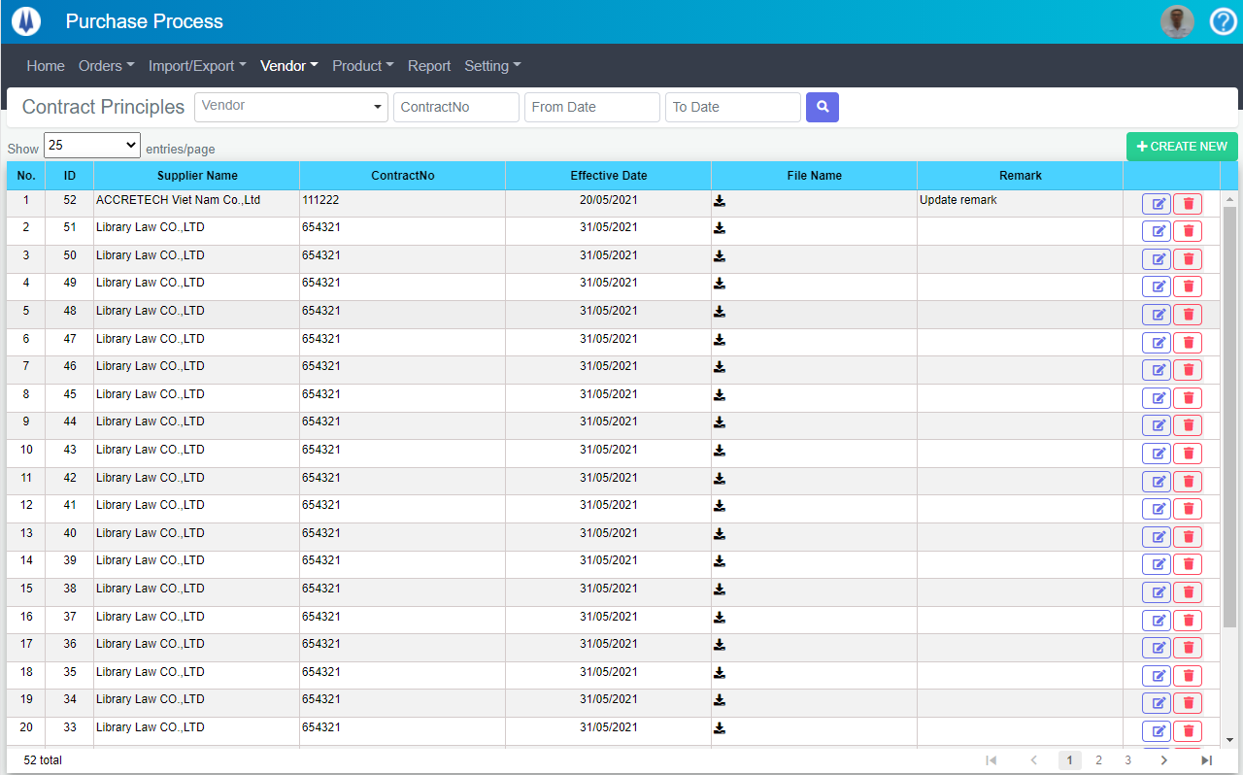

Open “DeleteContract” popup

Open “EditContract” popup

Open “AddNewContract” popup

Search item by highlight fields

Change page of List

Select display rows per page

### Create new Contract Principles:

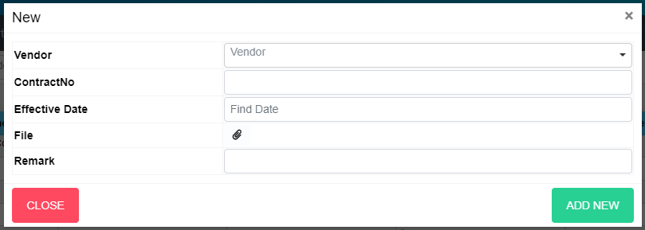

Create New Contract

Close popup Create New Contract

### Edit Contract Principles:

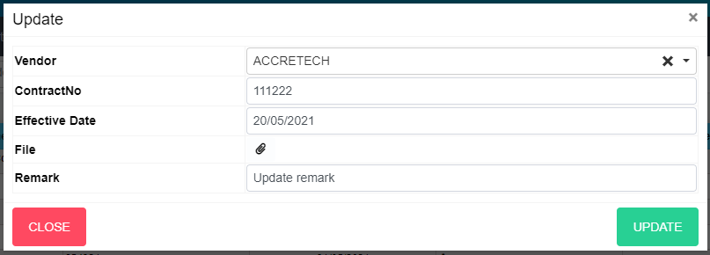

Close popup Edit Contract

Update Contract

### Delete Contract Principles:

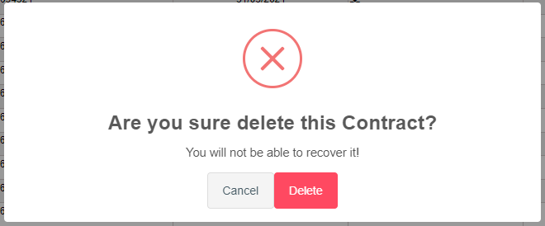

Close popup Delete Contract

Delete Contract

## Supplier check:

### Supplier Check list:

In menu click to “Vendor”, choose “Supplier Check”

Supplier Check List will show as below: 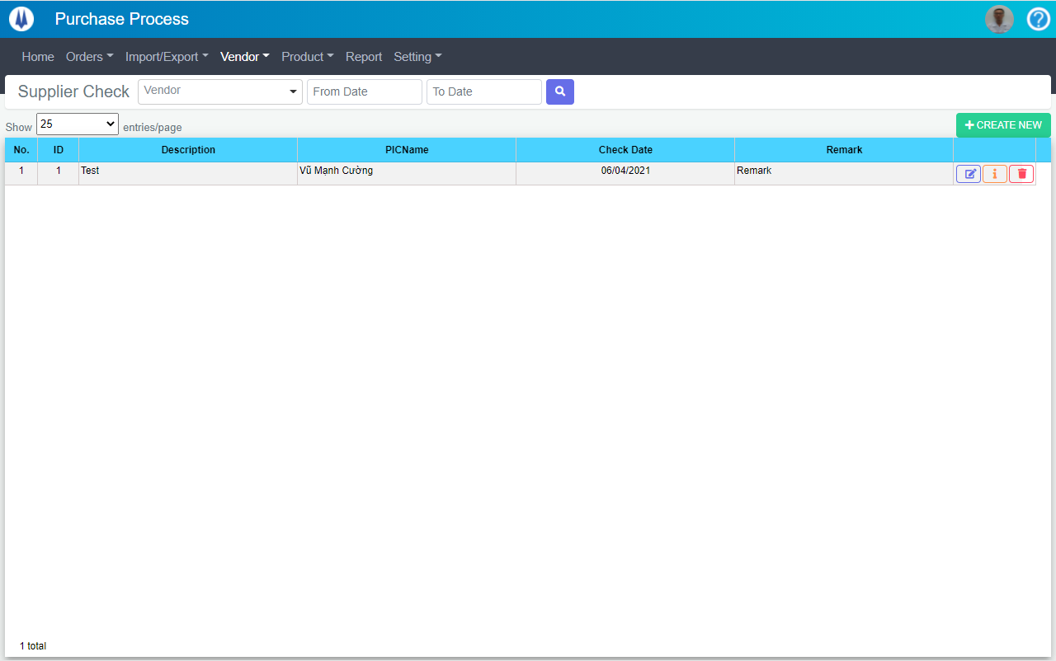

Open “DeleteSupplierCheck” popup

Open “DetailSupplierCheck” popup

Open “EditSupplierCheck” popup

Open “AddNewSupplierCheck” popup

Search item by highlight fields

Select display rows per page

### Create new Supplier Check:



Create New Supplier Check

Close popup Create New Supplier Check

### Edit Supplier Check:

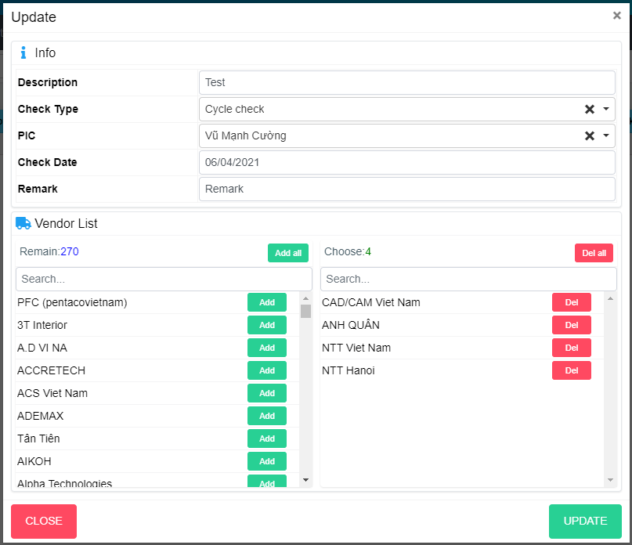

Remove item from Choose list to Remain list

Remove item from Remain list to Choose list

Remove all item from Choose list to Remain list

Remove all item from Remain list to Choose list

Close popup Edit Supplier Check

Update Supplier Check

### Delete Supplier Check:

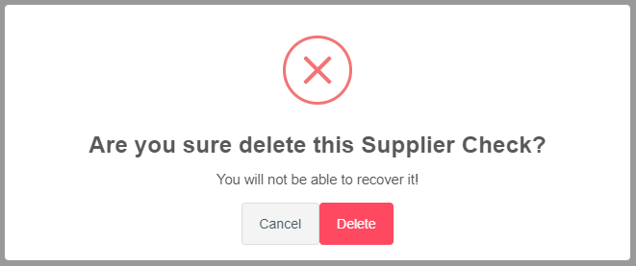

Delete Supplier Check

Close popup Delete Supplier Check

### Detail Contract Principles:

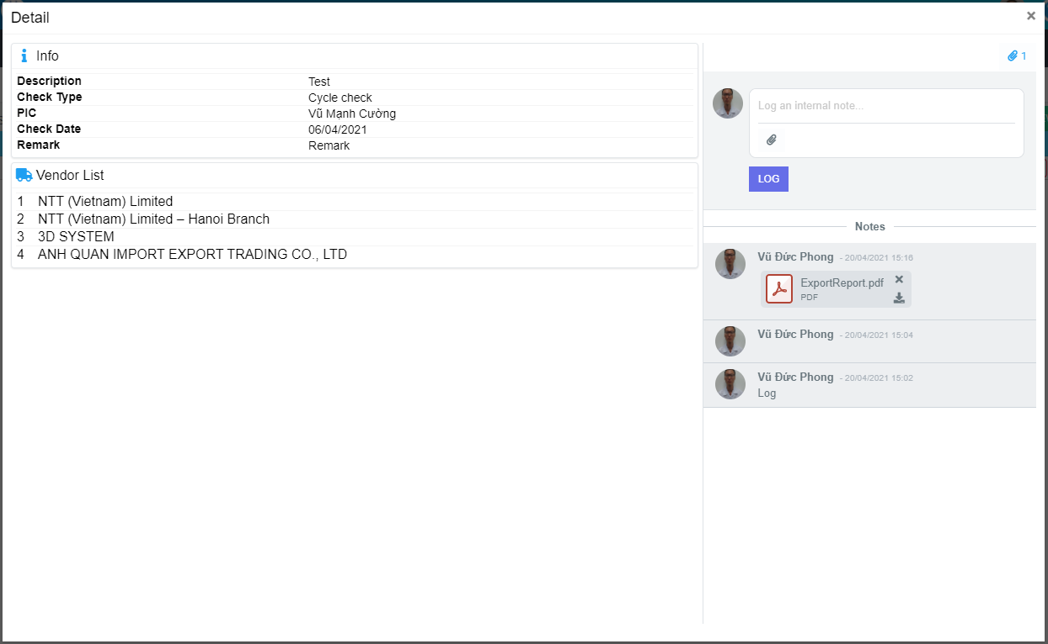

Remove file

Download file

Log

Choose file to upload

Show/Hide attach list

## Mistake Type:

### Mistake Type list:

In menu click to “Setting”, choose “Mistake Type” 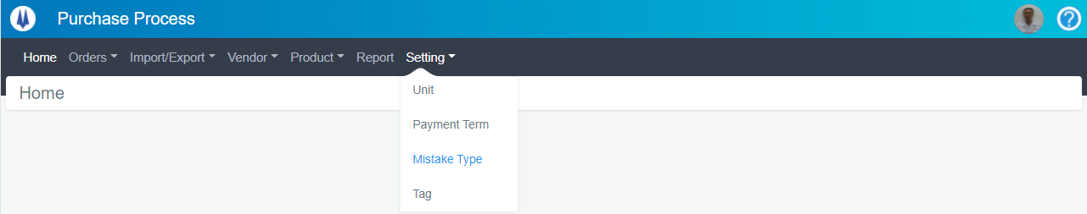

Mistake Type List will show as below: 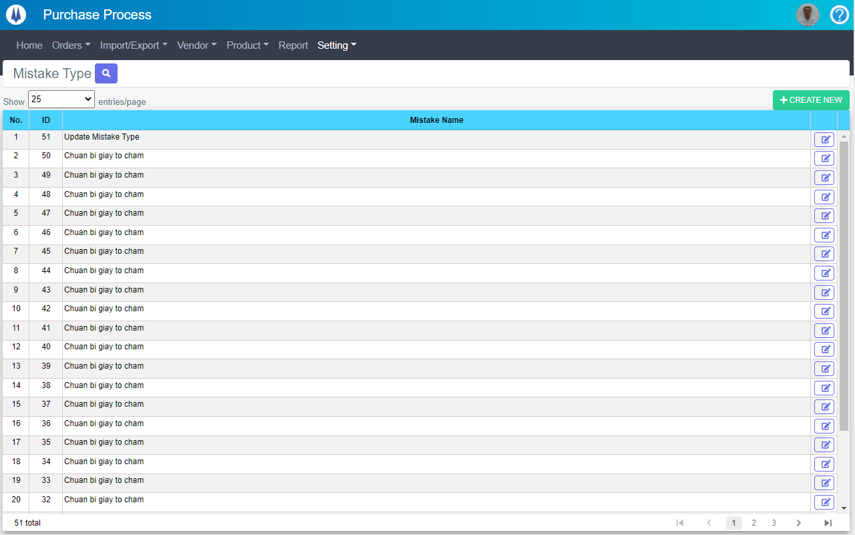

Open “AddNewMistakeType” popup

Open “EditMistakeType” popup

Select display rows per page

### Create new Mistake Type:

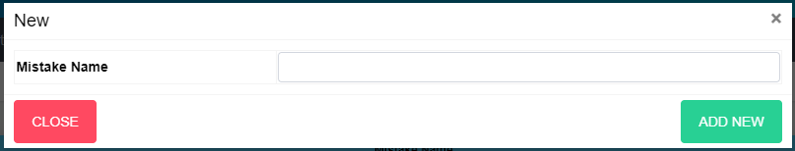

Close popup Create New Mistake Type

Create New Mistake Type

### Edit Mistake Type:

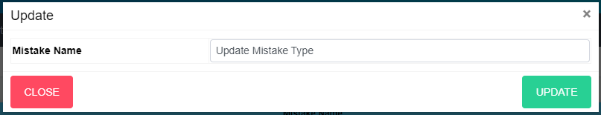

Close popup Edit Mistake Type

Update Mistake Type

## Tag:

### Tag list:

In menu click to “Setting”, choose “Tag” 

Tag List will show as below: 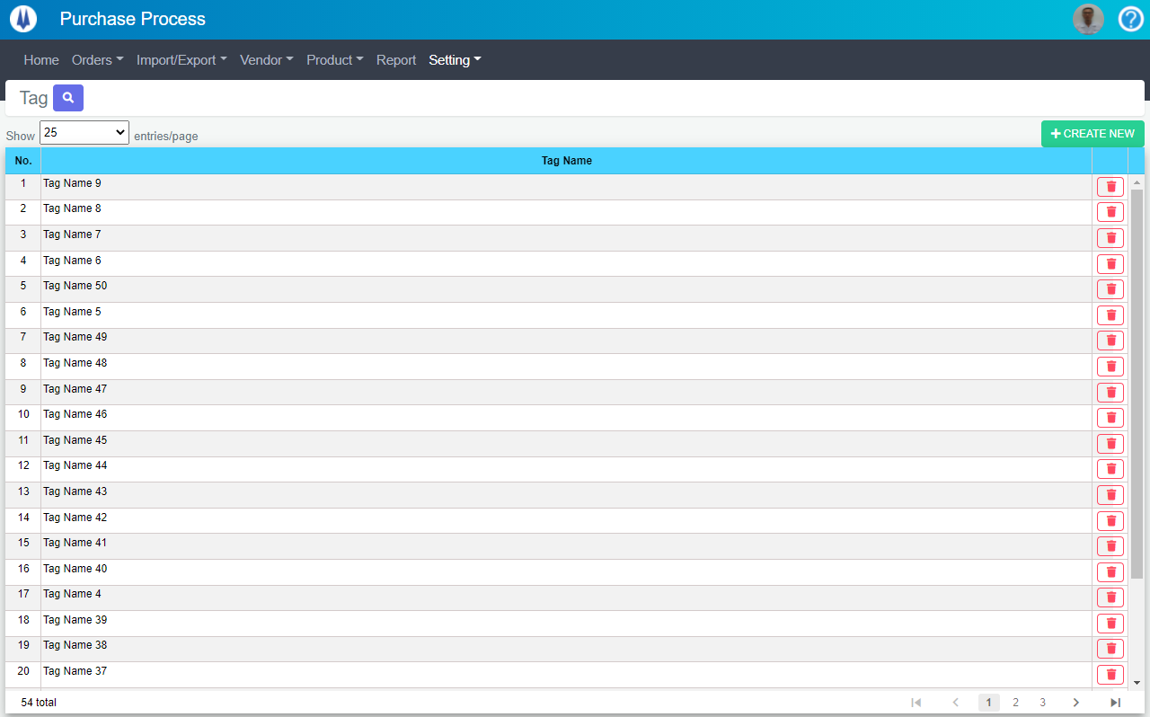

Open “AddNewTag” popup

Open “DeleteTag” popup

Select display rows per page

### Create new Tag:

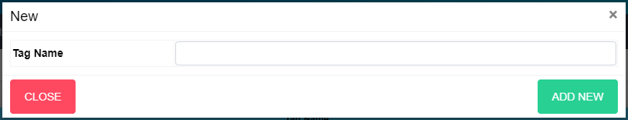

Close popup Create New Tag

Create New Tag

### Delete Tag:

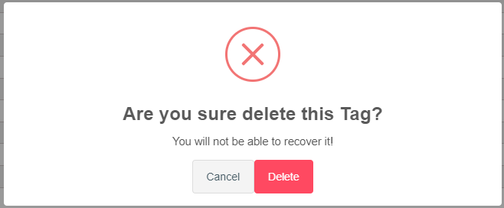

Delete Tag

Close popup Delete Tag

|  |  |  |
| --- | --- | --- |
| **STATUS OF UPDATING MANUAL** | | |
| **Version** | **Date** | **Reason** |
| E00 | 22/03/2021 | Make new |
| E01 | 29/04/2021 | Update: add more ThemeNo input, Budget description to “Create New PR” screen (page 10), “Edit PR” form (page 11) and “Clone PR” form (page 12). |
| E02 | 04/06/2021 | New modules: Import, Export Request, Export Request Check, Export Order, Vendor Claim, Supplier Check, Contract Principles, Mistake Type, Tag management. |
|  |  |  |
|  |  |  |